**WATECHPARK**

SMART Parking Lot System

**Vikas Sharma, George Alexandris, Elias Sabbagh**

|  |
| --- |
|  |

January 15, 2020

Computer Engineering Technology

Status

/1 Hardware present?

/1 Title Page

/1 Declaration of Joint Authorship

/1 Proposal (500 words)

/1 Executive Summary

# Declaration of Joint Authorship

We, Student A (Vikas Sharma), Student B (George Alexandris), and Student C (Elias Sabbagh), confirm that this work submitted is the joint work of our group and is expressed in our own words. Any uses made within it of the works of any other author, in any form (ideas, equations, figures, texts, tables, programs), are properly acknowledged at the point of use. A list of the references used is included. The work breakdown is as follows: Each of us provided functioning, documented hardware for a sensor or effector. Student A provided VCNL4010 Proximity Sensor. Student B provided IR Beam Sensor. Daniel O Donnell provided LSR Camera Sensor/2 Stepper motors. Due to unexpected circumstances, Daniel’s involvement with the project was passed to Elias Sabbagh joining the group during the Winter 2020 semester, to ensure successful progression of the project. In the integration effort, Student A is the lead for further development of our mobile application, Student B is the lead for the Hardware, and Student C is the lead for connecting the two via the Database.

# Proposal

**WatechPark**- SMART Parking Lot System Proposal

**From:**Vikas Sharma, N01160135

**Discipline:** Computer Engineering Technology

**Date:** January 15, 2020

# Background

This document will outline the software portion of the project in CENG 319 that will be coupled with hardware in CENG 317 for the final integration in CENG 355. Our project is going to be on a SMART parking lot system. Many busy parking lots are often plagued with congestion, drivers competing to find a spot by cruising around and visually finding spots. This is inefficient, time consuming where productivity is lost for consumers and businesses. The system we will be developing will address payment for parking, capacity management and location finding following an IoT approach using hardware and software.

# Problem Statement

The problem being addressed includes, time spent searching for a parking spot, increased capacity levels during peak hours. This project is focused on solving these issues by connecting consumers to parking lot owners and providing parking services by using a more convenient, simpler method to retrieve parking lot data seamlessly.

# Methodology

Phase 1: Hardware Design/Build

The small physical prototypes that we build are to be small and safe enough to be brought to class every week as well as be worked on at home. In alignment with the space below the tray in the Humber North Campus Electronics Parts kit the overall project maximum dimensions are 12 13/16" x 6" x 2 7/8" = 32.5cm x 15.25cm x 7.25cm.Keeping safety and Z462 in mind, the highest AC voltage that will be used is 16Vrms from a wall adapter from which +/- 15V or as high as 45 VDC can be obtained. Maximum power consumption will not exceed 20 Watts.

Phase 2: System Integration/Connection

This phase will be completed during the final semester of the Computer Engineering Program. The work gathered from both software/hardware courses will be combined and integrated for the final capstone project. The development platforms we will be working with is Android Studio 3.5.2, Raspberry Pi 4 Model B, and Google Firebase database. The mobile application provides key functionality to allow consumers to access parking lot data, view sensor/effector information specific to a location and choose the best parking space during different peak hours of the day. The VCNL4010 Proximity sensor will be used to detect the status of a given parking space at a specific time of access. The IR Beam Sensor will control the gate opening/closing and detect the presence of a vehicle near/far away. The LSR Camera sensor will be used for valid license plate recognition. The 2 stepper motors will control the gate and allow entry/exit based on the sensor data, and status of the lot.

Phase 3: Final Demonstration to Potential Employers

At this stage, we will demonstrate our 2 semester’s worth of work to be assessed. Our project description/specifications will be reviewed by, Mike Wrona, ideally an employer in a position to potentially hire once we graduate.

# Hypothesis

This project is focused on providing a solution for managing parking lot data, providing a less time-consuming experience with a simple, intuitive interface. This is an opportunity to showcase our knowledge and understanding to build a collaborative effort for an industry sampled IoT project. I request approval of this project.

# Executive Summary

In retrospect, this document outlines both the hardware and software aspects of the project. This project intends to build an IoT design that would help support industry related issues such as capacity management, location-finding by finding ways to reduce the time spent manually searching for parking spots. This document aims to provide insight into the design, development, testing phase of our SMART parking lot system project. In collaboration with our partner at ParkingBoxx, we have gathered our ideas to create a simple, intuitive and user-friendly platform for consumers within the market.

Our product aims to provide the essential needs for both consumers/businesses to view and manage parking lot data. In terms of market use, we believe through the project we will build a product that can be offered from an industry standpoint as well as be marketable to other fields of interest. Through the development of this product, we wanted to reach as many demographics and be able to provide an inexpensive and reliable platform where parking lot information can be retrieved at a glance. We offer users with the ability to be able to add/manage cars, view parking lot data, make on-the go reservations for parking passes, accessible via an online database to send/receive information in real-time, all built-in with a simple, effective interface. Due to these reasons, we believe it will be ideal to be considered to be hired by an investor for employment. This will be an extraordinary opportunity for us to be able present our work, knowledge and skills to promote our product from a marketing perspective.

# 1.0 Introduction

This report will outline the development and integration of our final capstone project as part of the Computer Engineering Technology program at Humber. The individual team contribution for this project goes towards George Alexandris, Vikas Sharma, and Elias Sabbagh all 3 of whom were extensively involved with bringing the project to life. The focus was to implement an IoT (Internet of Things) design, where software and hardware interaction would be vital to address an industry related issue and help solve real-world problems. This project consists of a SMART parking lot management platform, which allows consumers/businesses the ability to manage and monitor parking lot data through real-time progression. The goal, being to address problems arising in the parking industry specifically in terms of capacity management, increased manual interference, and the lack of location-finding near/far from an area. The product looks towards determining the challenges in the parking industry today, and provide a platform to navigate to a parking space quicker, and in a more efficient manner. This includes, managing parked users, or monitoring the status of a lot at a given time. The main objective of this undertaking is to provide a more efficient and reliable platform to aid with parking scenarios. In particular, for the purpose of the consumer demographic who’s in the market for an alternative parking lot management system. Our focus was to develop a platform, that would be the gateway to support consumers with finding the best parking space during any time, any place or anywhere in the world.

# Project Schedule

The following is an overall breakdown of our work schedule for the duration of the entire project, and the two consecutive semesters:

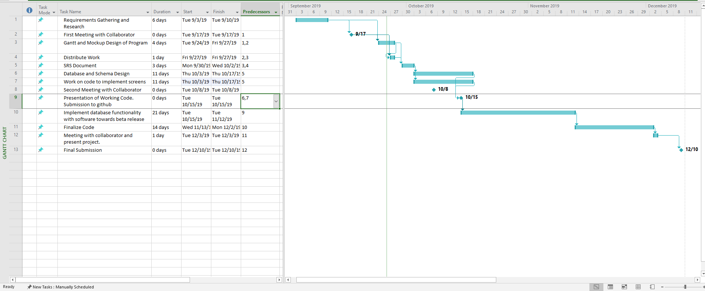

Figure 1 - Gantt Chart (Software)

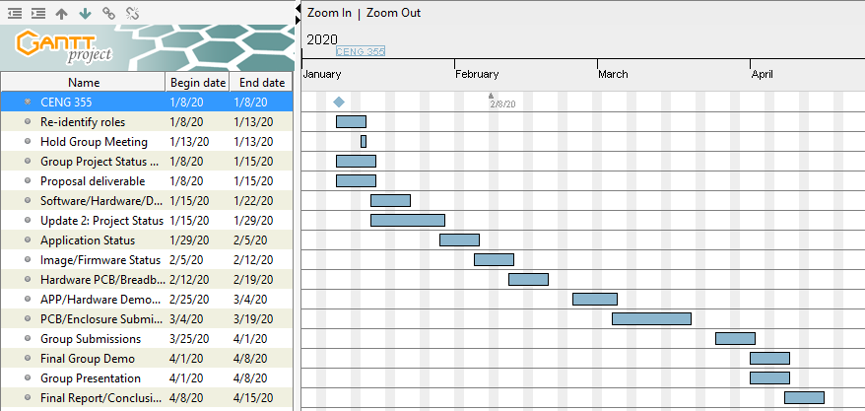

Figure 2 - Gantt Chart (Final Breakdown)

In terms of overall scheduling purposes, the project requires approximately fifteen weeks to complete during the Winter 2020 semester of the Computer Engineering Technology program. During the start of the final semester, the work done from the previous fall 2019 semester from CENG 319 and CENG 317 was carried over to complete the final integration. Most of the software development portion of the mobile application, and the connection to the database was done during the fall semester. Our group also ensured we were on the right track, by ensuring at least one of our team members can connect their sensor data to the database to send/display data to the platform during the fall semester. The core amount of work was accomplished towards the end of the Software Programming course, as well as in the Hardware Production Technology course. Our team followed our planned schedule efficiently throughout the fall semester, and carried the workload into the Winter 2020 semester. The final semester needed the group to finish implementing the sensor data to the Firebase database to be able to read/display data from the actual hardware. At this time, our team will extensively focus on completing the mobile application, and adding its intended features. As well as, re-designing our PCB boards to accumulate all three sensors from each team member into a final PCB design. The final semester will be used appropriately to ensure successful completion, and a polished end product.

## 1.1 Scope and Requirements

This report will address the key fundamentals of the project, including the software/hardware aspects of the design/specification and the final integration between these applications. It will touch on how the hardware (sensors/effectors) communicate and interact with the software application to allow consumers to track parking lot data. Further details will be examined in this document, in regards to the hardware sensors used, the main objectives behind choosing the type of hardware and how it correlates to the application being developed. Along with, describing the database structure used to push and retrieve data from the hardware to the mobile application, and vice-versa. In terms of the scope of the project, there were instances where the planned outcomes from the initial stages of the development period had to be modified or re-considered. This includes, having some minor design/features changes and removals mainly due to time constraints or software limitations, to further increase productivity and meet the overall requirements. Some of these changes included, a major overhaul of the main Home screen to provide a smoother, sleeker interface for user interaction, removing Google API login integration, removing the search function from the mobile application after much consideration. A major change, occurred during the Winter 2020 semester, where our development team decided it was in our best interest to not move forward with the development of the business aspect of the application. This feature would have allowed users to track their daily progress and set goals to reach in the mobile application from a marketing standpoint. The team decided to improve on the existing consumer functionality instead, with implementing the proposed camera sensor functionality, and stepper motor gate control. Due to this reason, these features had to be omitted as a result of not meeting the plan, and the overall extent of the project had to be re-evaluated and worked on. Our team followed an agile methodology/procedure where work would be committed and evaluated on a daily basis to ensure the team stays on track. Development was split into distinct sprints of software coding/hardware testing to ensure both applications are met within the due time. During this time, coding was separated into blocks of development periods where the team focused on completing a single feature, and aiming towards further progression from both sides. The limitations provided our team with an outlet, to focus on the main goal/priority and cut down on excess amount of work that can be evaluated later in terms of a marketing perspective. For example, one of the ideas the team came up with was introducing the business aspect through an online website where users would be able to view financial, user information along with providing identical software/hardware interaction. This SMART parking assistance platform provides real-time proximity measurements, lot detection methods with use of the hardware elements. Such as, the entry/exits of vehicles, detecting parking space movement, gate control.

## Development Platform Specification

The following are the specifications of the software side of development. In terms of application use, consumers only need to know how to use a smartphone device. No technical expertise is needed as the platform we develop will be simple to use and gain a grasp of. The following are the list of software requirements vital for the platform to operate as intended:

* Android Studio 3.5.2 development platform
* Java (coding language) used for mobile application
* Software must have bilingual capabilities for English/French language integration
* Internet connection (Wi-fi) is needed to access the mobile application, and its main functions.

## Hardware Specification

The following is a list of hardware requirements needed by the user to operate the application, and its functions:

* Raspberry Pi 4 Model B (CPU platform to process sensor data)
* Must support at least 2GB of storage, RAM
* Embedded CPU (Raspberry Pi) device will always need a connection to the server for the purposes of authenticating users, and receiving data.

## Android Device Specification

* Must be running Android OS on mobile system
* Mobile APP will run only on Android devices
* API 21(Android Version 5.0 Lollipop) and above (supported roughly over 80% of the Android population)

## Database Specification/Protocols

* Google Firebase database for storage purposes, push/retrieve real-time data from sensors to mobile application, and vice -versa.
* User Authentication

**Protocols:**

* HTTPS/SSL Encryption end to end communication
* TCP/UDP Connection
* Wi-Fi/Cellular connection

**Server-Side:**

* Email: SMTP (Simple Mail Transfer Protocol)
* Data transfer rates must be capped to not utilize an excess amount of data, depending on connection type (size must be compressed).

Report

/1 Hardware present?

/1 Introduction (500 words)

/1 Scope and Requirements

/1 Background (500 words)

/1 References

# 2.0 Background

In the industry today, there have many occurrences where parking in general has become a hassle for city residents and parking lot owners. This includes, not possessing the right tools to manage capacity when a parking lot is full, where drivers are struggling to find the best spot to park their vehicles. This can lead to dis-satisfying scenarios, where drivers are unaware of their surroundings, before even entering into the space. Due to this reason, it can lead to congestion in major traffic centric cities, with drivers competing to find a spot. This can be time-consuming, inefficient where productivity is lost for consumers and businesses. This project is focused on helping reduce the impact of this cause, by developing a system that will address payment for parking by taking an advanced and modern approach towards capacity management, and real-time information gathering to keep consumers up to date with their daily occurrences.

The group would like to thank Mike Wrona, installation manager, of Parking Boxx who provided support for this project. The project is a SMART parking lot system that incorporates a phone app to manage a user’s tickets, account, and where to park in the parking lot. The idea of this project came up when the group realized that we can develop an easier way to find parking spots, by connecting all the spots to a parking app. We thought about creating an IoT parking lot that can connect to a database and update the database with information about its open/closed parking spots. It will be able to send and retrieve information about the parking lot. The mobile application will allow users to connect to the database and manage user accounts and payments for their tickets. Examples of some existing platforms are Indigo, BestParking, EasyPark and ParkWhiz. These platforms have reservation capabilities, on the go parking with mobile or web application. What we are going to do differently from these companies is to integrate sensors to help users navigate to a parking spot.

One of the parking companies we looked at is EasyPark(EasyPark, 2016). EasyPark offers monthly payments for its customers to park in the EasyPark parking facilities. The goal for EasyPark is “provide safe, clean, friendly, convenient and affordable parking to the Greater Vancouver community” (EasyPark, 2016). EasyPark offers a phone app (EasyPark, 2016) called EasyPark Parking as well that allows it users to view parking available at its facilities. You can pay for parking on the phone app (Google Play, 2020). The parking app allows its users to register, find EasyPark parking lots close to you, keep track of how long and where your car is parked in the parking facility. Payment is done through the mobile platform with a much simpler method of operation.

We looked at the other parking companies that were mentioned such as Indigo, BestParking, and ParkWhiz. In terms of overall design and interface almost each application had full resemblance to the previous. Indigo offers a map that allows users to choose which parking lot they want to park at. Users can book their parking ticket in advance, reserve the spot for the designated parking facility owned by the company they want to park at, and they can see the rates of the parking lots (Park Indigo Canada Inc, 2019). Apps such as ParkWhiz, offers the options to add cars for verification, pay for monthly parking on the app and their ticket (ParkWhiz, 2019).

# 3.0 Methodology

The following section will outline and extensively explain our method of operation for the duration of this project. This includes the steps taken to ensure we meet the correct criteria in reaching the end goal. Following an agile methodology, we will keep working diligently to get each part of the application up and running. In the event of any outstanding circumstance, we will review the design and re-assess which parts are causing the issue and work around from there. Development and testing phases of the project will be split into distinct sprints of development. The next few branches of this section, will go into detail in regards to the required resources. Initially, focusing on the parts/components/materials used to complete the project, the manufacturing process for PCB and enclosure, tools/facilities utilized, shipping/duty/taxes and lastly touch on the working time versus lead time needed to complete the final hardware integration for the project.

## 3.1 Required Resources

Report

/1 Parts/components/materials (500 words)

/1 PCB, case (500 words)

/1 Tools, facilities (500 words)

/1 Shipping, duty, taxes (250 words)

/1 Working time versus lead time (250 words)

### 3.1.1 Parts, Components, Materials

## Parts and Components

This project consists of a variety of parts, components and materials which were utilized during the development, testing and final integration phase of our parking application. These components were essential to different features/functionalities of the parking platform and vital in terms of performing each functionality of our application. The project made use of three primary hardware sensors/effectors. These included, the VCNL4010 Proximity Sensor, IR Break Beam Sensor (Receiver/Transmitter), USB Camera Sensor (YoLuke HD Webcam). The CPU Broadcom Development platform chosen for the project is the Raspberry Pi 4 Model B. The Raspberry Pi 4 is the fastest, latest piece of technology that is capable in providing multi-support interfaces, at much higher speeds. For large data processing, and data heavy projects such as this extensive project it is the suggested microcontroller to do the job. Firstly, for the VCNL4010 Proximity sensor, we made use of the following hardware components: 3 (220) ohm variable resistors to limit the current flow through the circuit, Common Anode RGB(red, green, blue) LED to detect and react to changing states in proximity readings/parking lot status, 20x2 stackable header, to mount the PCB board to the Raspberry Pi, 6 pin stackable header, to mount the sensor to the soldered PCB board, and finally a set of jumper wires(female to male) for the breadboard testing portion. For the IR Break Beam sensor, the components used included the following: 4.7K ohm resistor, 1.0K ohm resistor, and a red LED to detect movement of an object, in this case for our application it would detect if a vehicle is in the way of the gate to allow entry/exit as a result, breaking the beam. The Raspberry Pi 4 Model B microcontroller will provide the key functionalities for the VCNL4010 Proximity sensor, IR Bream Beam sensor, and the USB Camera sensor alongside the 2 stepper motors used for parking lot gate control.

Furthermore, other components used include a power supply alongside an Ethernet to USB (Universal Serial Bus) adapter cable. These components will provide the interface to connect to the Broadcom Development platform through either remote desktop connection or via VNC Viewer connection to further develop, integrate the sensor/effector functionalities. An SD card will be used to provide the imaging/firmware configuration settings from an Ethernet connection, using the universal serial bus to Ethernet adapter.

Along with these essential parts, multiple jumper wires were used to connect to the GPIO (General Purpose Input/Output) pins of the Raspberry Pi device. The VCNL4010 Proximity sensor, and the IR Beam sensor will be used under a I2C interface. Using a 40-pin stackable header for the GPIO pins of the Raspberry Pi, the VCNL4010 Proximity sensor and the IR Beam sensor will be connected to the Raspberry Pi using its general-purpose input/output pins corresponding to each circuitry design for each sensor. These sensors will then communicate based on the surrounding environment, and its conditions. For example, detect whether a vehicle is in the way of the gate or a space is being occupied/ statuses of the lot. These components will then interface through the real-time database setup through Firebase database to push/retrieve parking lot data/statuses actively. The USB Camera sensor will be used for license plate recognition and capture an image of a valid license plate at entry. The data captured will be sent to the database for further examination. More details in terms of the mobile application, and how the data is presented will be explained in the Development Platform section under the Mobile Application branch in this report.

Additionally, three stackable headers were needed to mount all three sensors to the PCB (printed circuit board) for the final PCB design process, further detailed in the Manufacturing part of this section. Our team focused on retrieving parts and components that were feasible and inexpensive to our planned budget and would provide the best quality of performance. The parts made use of for the project included the presented ones above, including the added components needed to successfully test and implement each sensor.

## Materials

The materials to be used as part of the project, includes the following: laser-cut acrylic for the final enclosure design, to protect all three sensors from potential harm/damage prepared in a suitable housing environment. Other materials included making use of a breadboard to test the hardware sensors and the corresponding circuits that were built. Some other materials used included, the printed circuit board constructed and etched through sheets/layers of copper foil, and glass fiber material (fiberglass epoxy resin). These dielectric materials, such as glass, fiber was used as an insulating layer to create the PCB from the ground up through both the top/bottom layers of the printed board. Through the laser-cutting work achieved for the enclosure, acrylic material will be used alongside plastic housing to support the hardware and provide panels for the safety of the Raspberry Pi platform, printed circuit board, and its sensors. Acrylic material is lightweight, superior in quality and provides the best resistance for each sensor housed in the case. Similar to fiberglass material, the enclosure will be able to offer a clearer insight into the different components and sensors/effectors and provide high protection for all hardware components assembled. All-inclusively, these parts, components and materials gathered will be important in the integration effort to ensure successful completion of the project, following our planned methodology and strategy.

### 3.1.2 Manufacturing

### PCB/Case

In terms of the manufacturing process, most of the components gathered were ordered through the Amazon, BuyAPi, and Adafruit industrial companies. The printed circuit board designed was also manufactured and produced by the prototype lab, free of cost.

The final PCB and enclosure designs were all discussed in this semester including completed PCB and case designs from last semester. Last semester in the Hardware Production Technology course we had to design PCB’s and enclosures for the sensors we required for the final Parking Lot project in this semester. In this part of the report, we will take a look at the previous designs of the PCBs and cases being used in the project, and how they will be integrated into one final design.

The IR Break Beam Sensor project was designed by George Alexandris. The IR Break Beam sensor had a few design changes over the Hardware course last semester. The first version of the PCB design for the IR Break Beam Sensor did not fit onto the Raspberry Pi 4 Model B. The size of the first version was too large to be put onto the Raspberry Pi. The second size of the PCB was smaller and was able to be fit onto the board successfully.

Below are images of the second version of the PCB in Fritzing and the printed PCB: 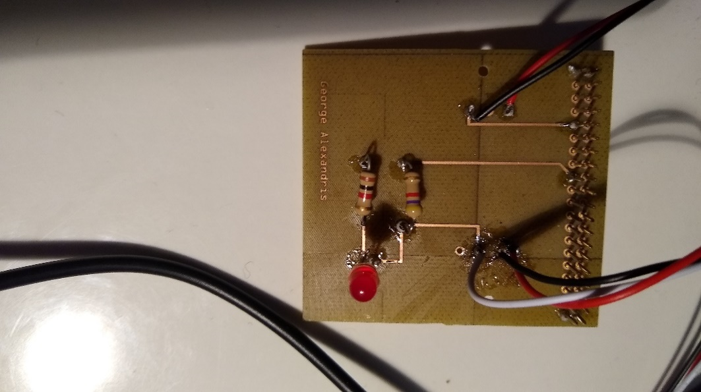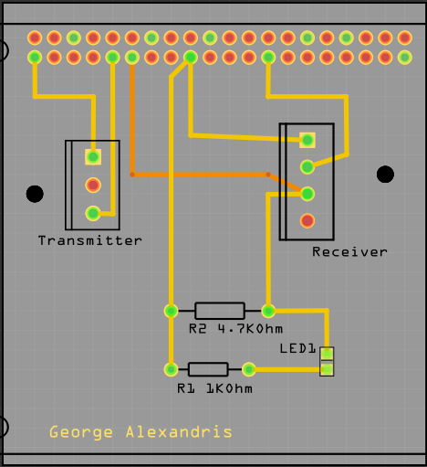

Figure 3: Printed PCB from Fritzing file Figure 4: Image of PCB Design in Fritzing

PCB’s were all designed in a free program called Fritzing and were printed in the Prototype Lab at Humber College. IR Break Beam sensor is in two parts one is the transmitter which as two connections directly to 3.3V power and ground on the board. The other part is the receiver which has three connections one for 3.3V and ground directly to the Pi while the third connection is to one of the GPIO pins. The GPIO pins can be setup for either input or output but the third wire from the receiver is a digital output so the GPIO pin it is connected to is set up as an input to read the value from the output wire.

The enclosure design for the IR Break Beam sensor project went through many design changes as well. The design for the case had to consider the size of the Raspberry Pi and the PCB for the IR Break beam sensor. The cases were designed in CorelDRAW and laser cut in the prototype lab. Early designs for the case of the IR Break Beam Sensor Project did not fit the sensor and the Raspberry Pi together in one case. The PCB of the IR sensor was long and the early design for the enclosure was too small in length for the case to fit. The measurements were taken to adjust the size of the case so the PCB and Raspberry Pi can fit together. The new design was longer for the PCB and Raspberry Pi to fit and the final design is shown below.

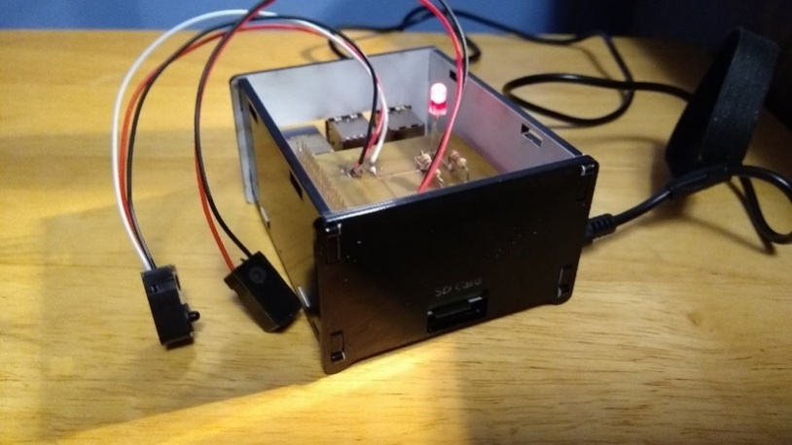

Figure 5: Final Case Design for IR Break Beam Sensor

The second sensor being used for the project is the VCNL4010 Proximity/Light Sensor. The PCB and case for this sensor was designed by Vikas Sharma. This step required use of the Fritzing software, which is an open-source application that allows users to visually create schematic, breadboard designs and finally incorporate their designs into a printed circuit board to be sent for etching and laser-cutting services. Over the course of the semester, Vikas had many different design flaws for the PCB. This was due to connections to the top layer of his PCB. In previous designs there were overlapping connections for the top/bottom layers, so Vikas had to redesign his PCB many times to not overlap his connections. The connection for the GPIO pins has to be on the top layer because of soldering the PCB to a 40-pin connector for the Raspberry Pi, it is not possible to solder the bottom layer.

To solder the PCB board, you would require a lot of focus, and attention, because any accidental procedures/connections going wrong can cause you to redesign the whole board. Vikas was able to luckily not have to go through that process, while soldering. For his design, there were 4 vias that needed to be soldered. You must thread a single thin wire through the holes, solder it and then cut off the remaining excess wires. The same process, was taken for the resistors where Vikas set up the resistors in their place and had to solder the 2 sides. Then, cut off the excess wire. While soldering the LED, Vikas had to be very cautious as the connections were designed really close to each other, so a lot of focus was needed here. Initially, there is a 6-pin header that comes with the sensor that needed to be soldered. Vikas also soldered the 40 pin GPIO pins on the PI, to keep the header stable while soldering and to create a sturdy connection. After soldering, the board should be ready to be tested, and should look like the screenshot shown on the left below.

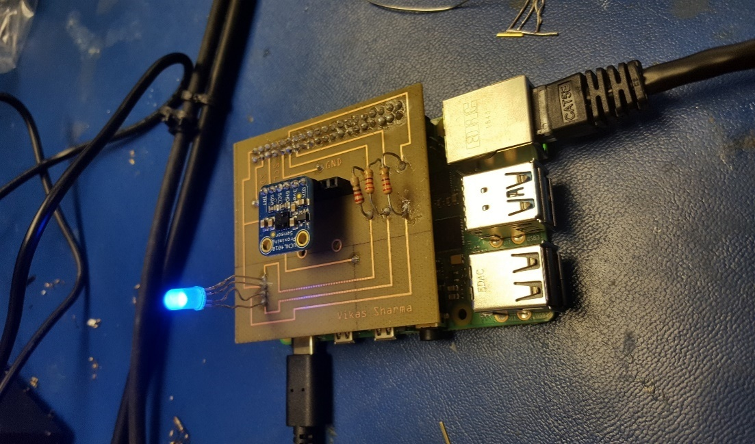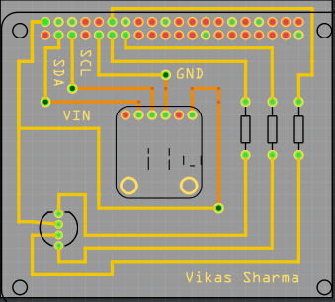

Figure 6: PCB final Design for VCNL4010 Figure 7: PCB Design for VCNL4010 in Fritzing

Once the PCB board testing phase was successfully complete and Vikas was retrieving/sending data to Firebase and the mobile application, he moved on to the enclosure design . For this, he decided to use the CorelDraw software as it seemed like the best choice to design the case the way you want. Vikas went with a acrylic case design, as the case is to prevent/protect your Raspberry Pi and sensor from potentially being damaged. While making the case , you have to be aware of the dimensions of the Raspberry Pi(height,width from all sides). For the design, he had to make some changes due to using the Raspberry Pi 4, some ports are arranged differently. Such as the LAN(ethernet port), and the 2 micro HDMI ports. For this, Vikas decided to make a wider port/hole to fit both mini HDMI ports into one. Vikas ran into a issue where the hole for the power port was cut too short, for this he had to shave off some excess acrylic to get the hole to be wider, to fit the power cable into the port. Vikas was able to fit it perfectly in the outcome. For the design, Vikas kept the top of the case open with a medium-sized hole, as there needed to be a object in the way of the sensor or far away for it to display the readings.Once all the requirements for the dimensions of the openings were met the final case design was complete.

14

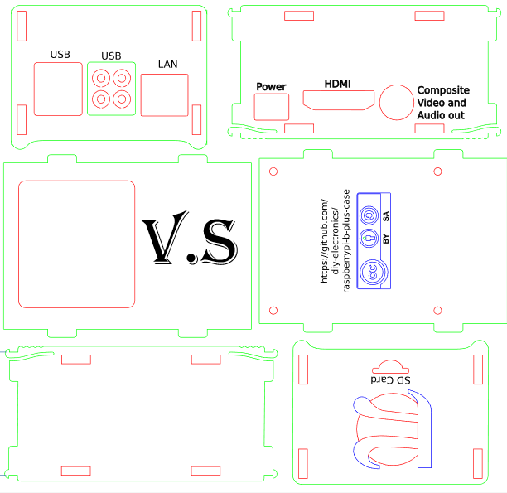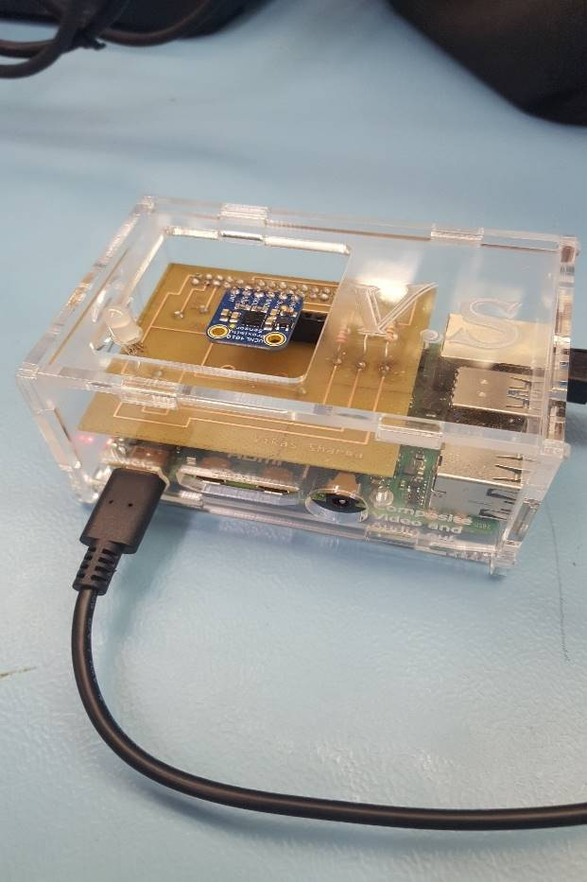

Figure 8: Final Case CorelDRAW design for VCNL4010 Figure 9: Printed Case for VCNL4010

The last sensor, Yoluke HD Camera Sensor, did not have a design for an enclosure and its PCB since it is just a USB camera. The servo motor however, does have a PCB design and will be shown below.

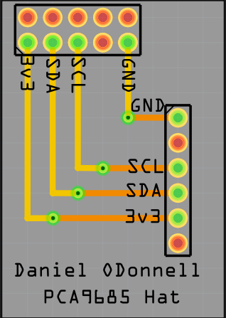

Figure : Fritzing PCB design for Servo motor

Taking into account the previous semesters work, the initial plan which will be immediately targeted is to combine all three sensors into a single printed circuit board entity. This will be done to ensure progression of the project, and meet the requirements for this semester in completing the capstone project. After testing each sensor, and connecting it to the database and the mobile application we will design a new PCB using the Fritzing software. This will enable us to work with all three sensors using only one Raspberry Pi 4 Model B Broadcom Development Platform, connected to a single PCB in the final stage. Elias will be responsible for helping with the hardware implementation and design the final PCB through the open-source software. Along with gaining further support from Vikas in working with the VCNL4010 Proximity sensor, IR Break Beam sensor, and the USB Camera sensor to read/display the values according to the parking lot data/changes in status. Using the I2C interface we will design the final PCB through integrating each sensor into a single design for multiple sensor support. The IR Beam sensor will be extensively tested for the gate control mechanics and George will be accountable to ensure the hardware functions as designed.

Towards the final stages of the project, a re-design of the enclosure will be needed for a cleaner, sleeker and compact design. It will be important to house all three sensors which will be part of the final PCB design, and create a suitable and appropriate design to meet the requirements for each sensor. A collaborative effort will be made from all three members of the WatechPark developer team here, to redesign and refine the casing using the CorelDraw software. The prototype lab will be used for further inspection, and laser-cutting services during this phase of the project. Generally, this section helped explain the design process/experience with the hardware PCB and case. This included, providing an individual look at each sensor, and its printed circuit board design process and the work that was put into each hardware project initially. Finally, this section addresses the final PCB, casing design and integration that will be the focus for this semester with the criteria mentioned above.

### 3.1.3 Tools and Facilities

Throughout the duration of the project, for accommodating both the hardware and software side, it was necessary to work with a set of tools and environments to ensure successful completion, and the planned outcome for each hardware component. The tools used to complete the project ranged from the initial design, development, testing and presentation phase of the overall end product. To begin, in terms of the PCB (printed circuit board) process, was the requirement of using copper wire, and the pin headers that came with each sensor, wire strippers to cut off excess wire during soldering the PCB together. The copper wire would be used to solder the components on the printed circuit board together, using a soldering iron provided by the Prototype Lab in Humber College itself. The soldering iron was available from the parts crib and most of the soldering was done in the prototype lab itself. Wire cutters were used to cut off excess wires from soldering the vias, or cutting down on extra wires from the components used for the PCB.

The computer lab facility provides the most necessary components at your disposal. This includes, the PC system itself where most of the configuration was done for each sensor, a soldering iron including the solder itself. Major work was accomplished in the prototype lab, where the solder was received through the parts crib and was used in conjunction with the soldering iron available at the station. The following steps were taken to solder, firstly it is recommended to heat the soldering iron before applying the solder at 360-470 degrees Fahrenheit. The solder can then be applied to the tip of the soldering iron to produce the best results before starting the process. Other tools used in the production of the PCB (printed circuit board) included a helping hand. This tool allows you to reposition the PCB at different angles to solder from different perspectives, to avoid any overlapping connections or accidently joining a connection together. This tool is used to angle the printed circuit board and hold the board while you solder the components as necessary, without having the need to manually re-adjust the board at different times of soldering.

The facilities used in the project, included the prototype lab in Humber College. This facility is the main source of providing the services to etch the PCB board during its final stages of production, as well as provide the laser-cutting services for the final enclosure design. This facility was used to solder the components, sensors together on the PCB and test the final design. Through this environment, we were able to learn the process of soldering, and using the human resources in the facility we were able to make the best decisions, or re-think our strategy to solder the PCB. The facility provided us with more viable options, recommendations and the best way to overcome any issue we were experiencing. This included, designing the PCB board, using the CorelDraw software for housing the sensors in the final enclosure developed. Adjustments were made depending on the different scenarios, and based on the advice of Vlad and Kelly whom were present to help. Along with their support, we were able to come to re-assess, learn and fix our design mistakes to create a more polished end product for both cases. These services were provided by the prototype lab, for both etching and cutting services for the printed circuit board and the acrylic casing, with a laser-cutting machine being available to us without any cost. Overall, these tools and facilities supported our team and our project in achieving its goals and provided us with the outlet of both human and machine resources. This was accomplished through the help of others in the facilities, or through etching and cutting services provided to meet the project requirements in the end.

### 3.1.4 Shipping, Duty, Taxes

Budget for the project will be discussed in this section in terms for where we ordered our parts, how much it was shipping, taxes and totals will be shown. Most of the parts were ordered from last semester. George ordered all the parts he needed for the IR Break Beam sensor project, Vikas ordered his components necessary for the VCNL4010 Proximity/Light sensor and the final parts were the 2 Servo Motors and YoLuke HD Camera Sensor.

The components utilized for this project were ordered ahead of time to ensure work can be progressed or to test any faulty hardware piece for a quicker solution. Shipping time for most of the components was divided between 2-5 days, depending on the type of service chosen at the time of the transaction. The shipping options ranged from DHL Express shipping which transits worldwide and internationally. For example, for Vikas’s case while ordering the VCNL4010 Proximity sensor and its components at the time of the order, he chose he option of DHL Express shipping. This method of shipping provided, a much faster, reliable form of service with the components arriving roughly 2 days later from when the order was placed. In this case, the shipping cost was divided between two totals as shown in the screenshot below in the red outline. The shipping method and time required was lower than expected with other methods of shipping requiring 5 business days to ship the product from the source to the destination.

Duty was not placed, and avoided at all costs during this time to prevent any further costs from materials being shipped internationally or from other countries. For George’s case, most of the products shipped were either from Amazon, or through BuyAPi, with a single purchase for the IR Beam sensor being through Adafruit. The method of shipping was also different here, as with Amazon it provides the option of Amazon prime shipping. This depends upon the location the component is being shipped from of course, and based on that location, the time is calculated to ship the product out. Although, with Amazon Prime shipping most orders placed during a significant time of the day can be processed, and shipped within 2 days and delivered at a much quicker rate. Other hardware parts required a shipping time of 2-5 days with UPS or different forms of shipping requiring higher costs, if the item is needed within a set amount of time. For the most part, the components used in this project were shipped out within 2-5 days, and duty expenses were avoided to ensure an inexpensive project or to avoid any further delays.

Taxes were applied accordingly as well, with US (United States) tax rate being applied to the parts that were purchased through online shopping. Since these rates were in US dollars, we had to convert this value into CAD(Canadian) currency with the rate of 13% being applied instead as displayed below.

Below is the total project cost for the project, in terms for all the parts we all have currently in a BOM (Bill of Materials) format:

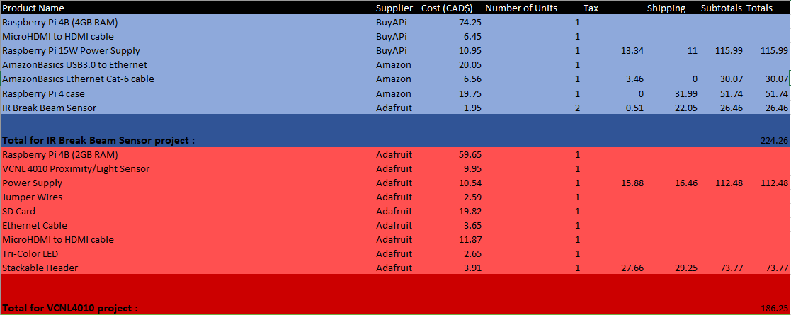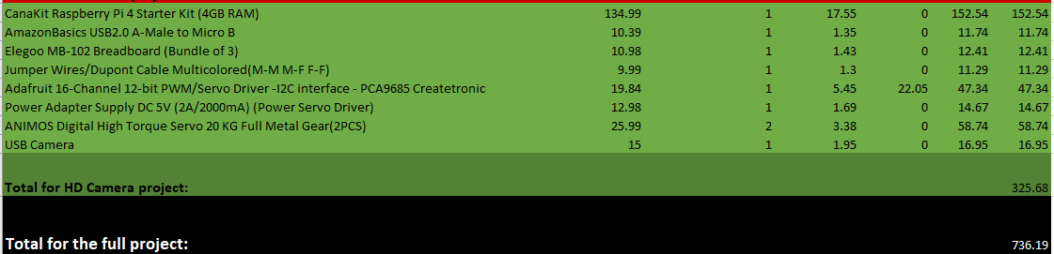

Figure 11: Final Project Budget

Most parts were ordered last semester and were used to complete their individual project. The total budget for the project is $736.19 CAD. The project total was calculated by adding up all the project budgets from last semester from each individual project. The projects involved are the IR Break Beam Sensor, VCNL4010 project and the HD Camera Project. They were all calculated from last semesters budget. There will be extra parts ordered for the final project and will be added to the total budget. These extra parts are not taken into consideration, the group is deciding on what extra parts we will use for this project. Such as, potentially ordering 3 more VCNL4010 Proximity sensor to accommodate our final parking lot prototype model with 4 parking spots. We plan on using all the parts ordered from the previous semester in the new semester. Some parts not considered in the budget are the parts being used from the parts kit such as some resistors and LEDs. The parts kit was purchased from the first semester and some of those parts are being used for the final project. This section helped provide a better insight into the shipping, duty and tax rates that went into ordering the components needed to complete the project and the financial state of the project before/after further development.

### 3.1.5 Time expenditure

Throughout the development of The WatechPark project, our overall time was split between hands on tasks, such as discussions, development, designing, building, debugging and testing, while the rest of our time was spent waiting for external tasks to be completed of a similar kind as parts delivery, laser cutting and PCB printing.

Please note that the time calculated in the following list, represents the total time spent by the three members of the project. For example, when discussing the time spent on designing the first PCB and the finalized PCB, in reality it reflects the collective time spent designing three PCBs for three different sensors and an additional three finalized PCBs for those sensors. This section of the report will touch on the total working time allotted to complete each requirement for the project, as well as address the amount of time needed to manufacturer the component from the total lead time. The following is the total breakdown of each section of both cases.  
Total of 105 hours spent as Working Time:

* 12 hours on project discussions and researching the required sensors and controllers
* 6 hours on finding the best vendor in terms or pricing and shipping time, and ordering the required parts, components and materials
* 6 hours on building and assembling breadboard prototypes
* 3 hours on voltage and safety testing for the breadboard connections before connecting our development platforms
* 6 hours on researching and installing the necessary third-party libraries for the sensors
* 6 hours on developing testing programs to be used on bread board circuits
* 6 hours on testing and debugging any anomalies in both the software code and the hardware connections
* 12 hours on designing and submitting both first and the finalized PCBs to be printed
* 6 hours on PCB assembly and soldering the needed components
* 3 hours circuit testing and safety verifications before connecting to the development platform
* 8 hours on designing, laser cutter submission and assembly of the PCB housing cases
* 15 hours on designing and developing the WatechPark android application
* 6 hours on Firebase initialization and filling up with data to be used with our android application
* 10 hours on testing and debugging our android application to ensure expected functionality with simulated sensor data stored in Firebase

Total of 22 days spent as Lead Time:

* 5 days on parts to be shipped and delivered
* 10 days on PCBs to be printed
* 7 days on housing case to be laser cut

## 

## 3.2 Development Platform

Our WatechPark application is centered on three main forms of criteria, this includes the front-end, back-end, and on-site devices used to interact with both the hardware and software aspects of the project. The front-end of our project consists around the use of Android devices/operating systems running Android Version 5.0 (Lollipop) and above. The main software utilized in terms of development, and further progression of the application was done through working with the Android Studio development environment. This was where a large majority of the coding, designing and software implementation was accomplished in terms of the mobile application side, which was then used to interface with the corresponding hardware elements. Coding was done through the use of the Java programming language, for further establishment of dedicated features or desired plans. This interaction was accomplished through our Broadcom Development platform, the Raspberry Pi 4 Model B. This CPU (central processing unit) was utilized to process the sensor data, readings along with the on-site devices, being the sensors/effectors used on location for our parking lot system. This will all be coupled with the back-end aspect, being the online database. In this case, the Firebase database will be used as a computational/server platform to retrieve real-time parking lot data, and allow the consumer access to parking lot information vital to a specific location. Collectively, these three aspects will serve as the primary connection to our project, and will act as the overall support structure to keep the work progressing through different heaps of development.

Student A (Vikas Sharma) will be addressing the development of the mobile application in this section.

### 3.2.1 Mobile Application

### Memo/ Mobile Application Integration

Initial development of the mobile application, began during the Fall 2019 semester as part of the Software Project class. During this time, our team worked extensively to build a system capable to store and retrieve parking lot data with use of an accompanying online database system. The Android application developed interacts with our Broadcom Development platform and the on-site devices, being the sensors/effectors to relay parking lot data, and monitor lot statuses at different intervals of the day. The goal for the mobile APP itself, being to allow remote access to parking lot locations and discover parking lot statuses in real-time through the working hardware assembled. The task presented for the duration of the semester, was to develop an Android mobile application that helps solve an industrial issue in the real word, working with sensors/effectors and an online database to delegate the data retrieved or sent. Based on our mockup designs created through the Balsamiq software program, we initially intended to focus development on two separate modes, consumer and business. We had planned to develop the consumer application during the Fall 2019 semester in the Software Project class, which we were able to successfully implement, with all proposed features, and some minimal changes/removals due to software limitations or constraints. The plan was to create the consumer side to allow the user to access parking lot data with a majority of the features being available at your disposal. The idea with the business side, was to allow the user to track daily goals, set goals for further achievement in the application, and view the overall history of parking passes purchased, payment details, or vehicles added to the system following an advanced approach. After much consideration, our team decided it was best to stick with the current consumer application instead, and focus on improving on the features already included, putting aside any business aspirations for potential future considerations. Instead of this idea, we devoted our full attention on the features needed to be implemented for the mobile application, and our parking lot system platform. This included, developing the functionality to allow access to parking lot data in real-time and view/monitor changes in status, rather than the current sample data coupled with the Home (Main Dashboard screen) in the application. This allowed us to focus on what is most important, and not waste valuable time on features that are additional or can be constructed in later development of the project. Therefore, the main reason to drop this idea being to the fact that it would have increased programming complexity and thus created more work to be done than is required.

Currently, our mobile application is capable of providing the key functionalities/features initially proposed during the startup phase of developing the application. This includes, allowing consumer access to a online database to monitor/display details on authenticated users in specific account information, login/register new or current users, make on-the go reservations for particular parking lots based on consumer choice, view parking lot details(in terms of sensor data, status of the lot during different instances), manage/add cars, select parking passes, payment, manage settings, help/about options. This includes, multi-support offerings of English/French language integration. Along with, automatic retrieval of transaction information through the Order History screen, working with the Firebase database to display the data back to the mobile application.

Features not yet deployed for the application, although planned to be implemented during this semester include the following: view a parking lot, monitor statuses of the lot, including overall capacity, gate entry/exit control and will help present a visual representation of the lot and the real-time changes through the use of the sensors/effectors. This feature will be implemented through this upcoming month, and work will commence in the upcoming days to ensure the feature is successfully completed by the set amount of time needed to complete the project. As of right now, our team is currently at pace in terms of continuing development of the mobile application, and actively listening for changes, removals or any potential additions to support the current state of the project. Fortunately, we were able to accomplish, and test each feature implemented from the previous semester at this time to make sure each planned feature works, and the key focus of the application is tackled. The application is designed to provide more functionality, and less cluttering of screens to encourage a further customizable experience, where the user feels comfortable using the application and its UI (User Interface).

### Login Activity/Authentication

At the start of opening up the application, the user will be prompted to a screen with options to log-in, register an account, or reset your password using the Forgot Your Password screen or Verify Your Password for different forms of authentication services in-application. We constructed an authentication process, in which we believe is a simple, intuitive interface for storing/checking credentials through secured database access. The following is a portrayal of the Register/Login screen which is automatically prompted to the user at entry of the application.

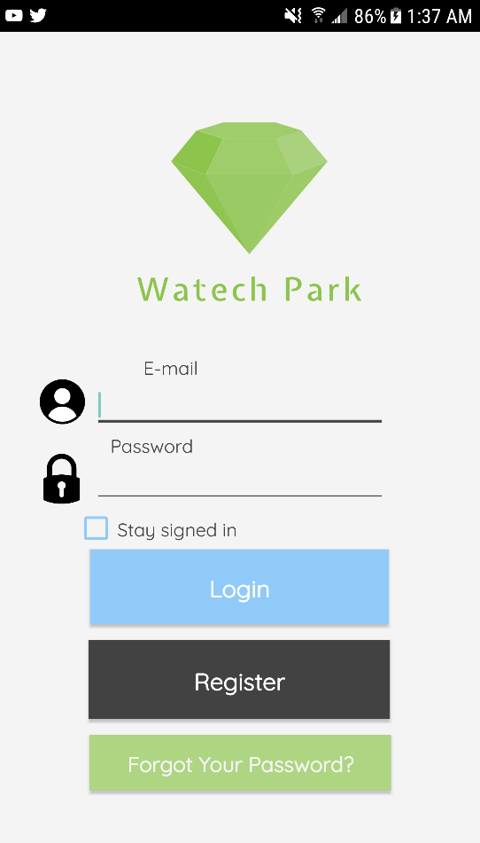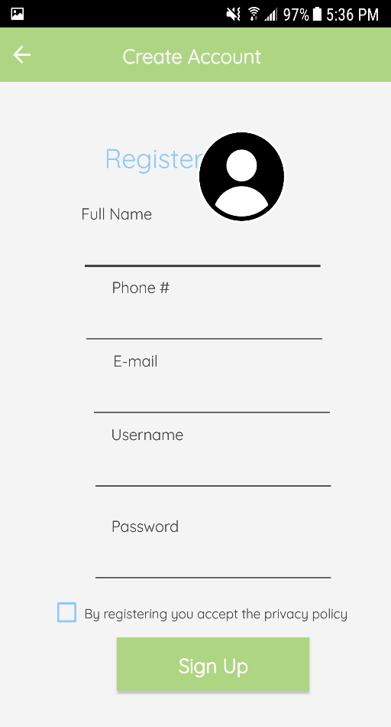

Figure 12 - Register Screen Figure 13 - Login Screen

The authentication part was designed with having a login/register screen separate from each other. The Register screen prompts user input in terms of personal information specific to a user. There is also the option for the user to choose a profile image from a real device through Firebase external storage permission. This account information is submitted onto the Firebase Real-Time database under a data structure, which holds the data. This information incudes, the full name, phone #, e-mail, username, image uploaded. So, once a user registers into the system the data is sent to the Firebase database, and stored to check for validation through login attempts further down the line.

After registering, the next step is to login. To login, we used the Firebase Authentication system for e-mail and password. This is a built-in feature of Firebase, that is used to authenticate a user that exists in the database. So, in the Login screen, the user would sign-in with the “registered” email and password. Firebase checks for valid/invalid credentials based on the information stored in the Firebase database section under that UID (unique identifier). User selections are stored with a “Stay signed in” option. This means, account information is visible after the user leaves the session, or returns to resume the activity. At this time in Firebase, the logged in user would appear in the Authentication section with the corresponding email/password information.

The authentication process continues with the “Forgot Your Password” and “Verify Your Password” screen. The Forgot Your Password screen is used to allow the user to reset their account password. There is the option to use e-mail or phone # authentication. This authentication is done through the Firebase database, where once a consumer selects a service, the other unattended service is not allowed to be accessed. The user enters an email address and through valid checking Firebase will then send a verification email to the corresponding email address. Phone number authentication requires the consumer to enter in a valid phone number using registration data from Firebase. Once the phone number has been validated, and follows the required system format (+1) a verification code is sent randomly through the phone service provider.

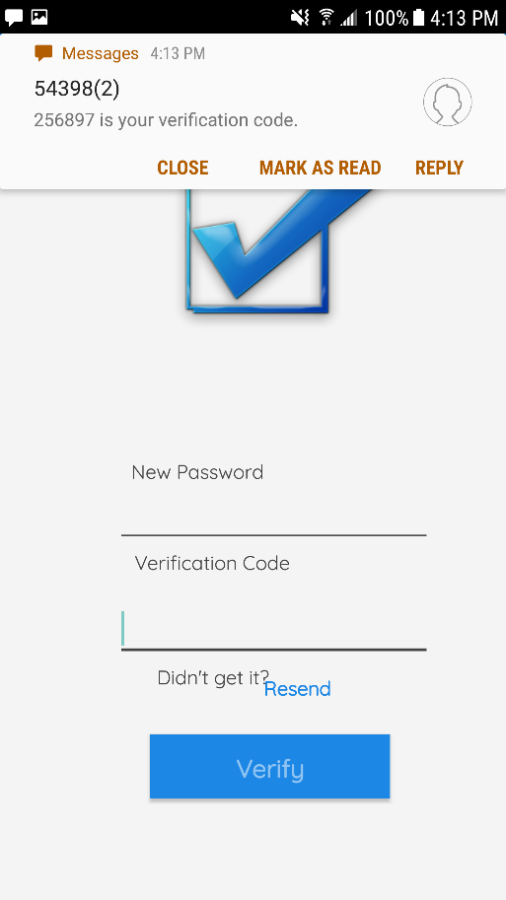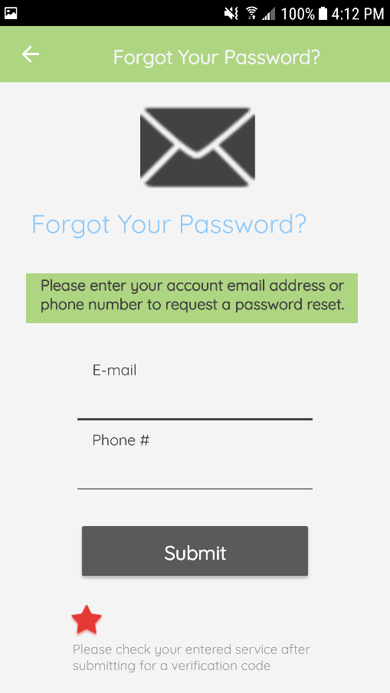

Figure 14 - Forgot Your Password Screen Figure 15 - Verify Your Password Screen

The mobile application also holds a feature, where account information is displayed specific to a user, in this case it would display different details based on the active UID. The screen followed a general layout, a little different from having to fit everything into a fragment view, we decided to use a new separate screen. This screen displays account information from the Register screen. The data is populated and displayed. Such as, the profile image stored from Firebase Storage, phone #, e-mail address, the name and a timestamp. Although, for this semester any current features/screens or designs are subject to change for that matter. we want to focus on the main functionalities of our application, and then move on to what can be added additionally, to further enhance the end product and meet the capstone project requirements.

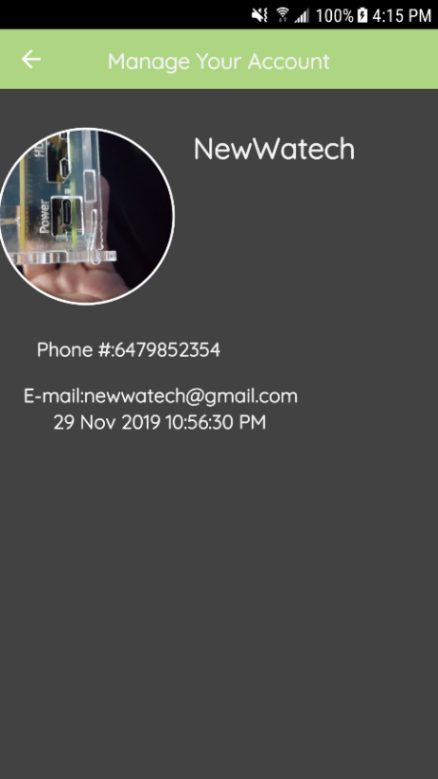

Figure 16 - Manage Your Account Screen

### Data Visualization Activity

Once the user has logged in, the main home screen appears. This is where the parking location data is displayed, and the sensor readings are gathered regarding each location with name, distance, and the total price of the parking pass. We believe this is the most streamlined approach taken for the users, and this allows easy and simple access of the data, and the activity all available within one main screen. This includes, proximity readings from the actual hardware, reservation capabilities, parking lot details and the actual lot itself visually represented in real-time. For this screen, we redesigned the main-menu from the proposed version, finally having a much sleeker interface to display each parking lot location, and its information to the screen in a more convenient manner. So, as shown above this screen offers two options to the consumers. This being “View Details and “Reserve”. View Details is where an expandable view pops up of the lot with an image, cost and the real-time proximity level of the lot at that particular time. At this stage of the project, our intentions are to build on from this feature, to provide access to the real-time parking lot prototype to be constructed during the duration of this semester. Currently, we are at the stage where we have figured out where the data will appear, once our physical parking lot model has been designed, and established. Then the goal here, is to modify this screen to show real data rather than sample data as is currently. The feature will allow further optimization of the hardware sensors/capabilities, with the plan being to provide the user with a visual representation of the application to go along with the physical hardware to be assembled later on in the upcoming month. Such as, display the parking lot and the parking spaces to be the focal point of testing purposes down the line. We have decided to create four main parking spaces, and these hardware aspects have to be mirrored within the mobile application. For example, the application will be able to show real-time changes in each parking space, individually or collectively and display data/readings fetched from the sensors. This includes, statuses of the lot (whether open/full), each parking space and changes viewed from the lot, gate entry/exits and the information will be displayed to the screen accordingly based on the conditions, from the actual hardware and sensors. Some of these conditions we have considered include the following: a vehicle enters the parking lot platform, the camera sensor on-site will immediately capture a image of the license plate, after validation/condition-checking entry is then allowed and during this time the data visible on the application should show four empty parking spaces in the lot. To indicate this, we will use three main colors: green, blue, and red. The light green will be used, when there are no objects/vehicles present in the parking lot. The blue color will be used to indicate a car is approaching and a message will appear on the application to guide the user to the next status change. The red will be used to indicate when a parking space is being occupied. Once a lot is full, the application will display this data through connecting to the database and receiving each sensor and its contents. So, in this case, entry will not be allowed further, so the application will be displaying a message saying “Lot A is Full”, or vice-versa depending on the situation. Further details on hardware will be discovered in the Breadboard/Independent PCB’s part of this section.

This data through the support of the hardware and the connection to the online database, will be further evaluated and assessed, to then be eligible to be displayed on the mobile application interface. This functionality is yet to be implemented into the final design, and will be the key focus throughout the upcoming month of March, and in Mid-February as it is the backbone/ purpose of what we set out to accomplish with this parking lot management platform. Currently, we have started initial development of the feature, and refactored the previous design into the new one, to further gauge on what is really needed and what features are not required.

Once the spot has been reserved, the corresponding data is sent automatically to the Parking Passes screen. At this time, the parking location that has been reserved on-the go, and its details as represented in the design are sent to Firebase through sample forms of data

If the parking lot has been reserved successfully, a notification pops up on the device presenting the reserved lot and to view the parking passes for the next step. By swiping to the left of the screen, brings up the side navigation drawer that is used to hold the main/other fragments and features of the application. This allows the user to access every main feature of the application within a gesture, and to avoid having to go through many hurdles or displays to get to their desired destination.

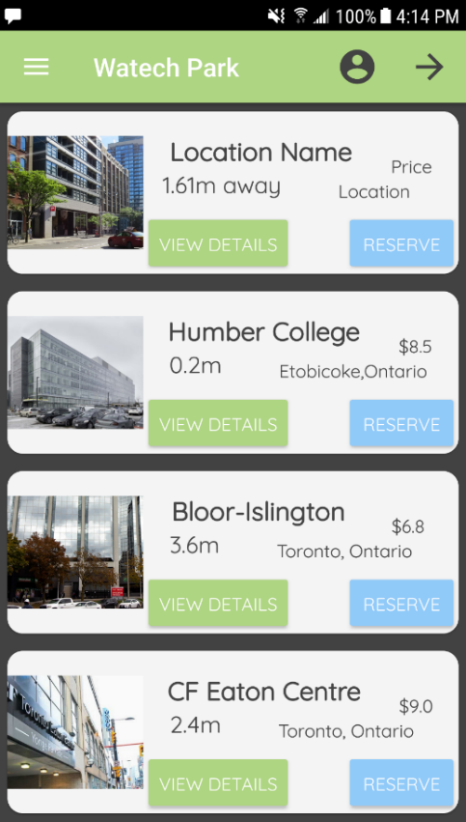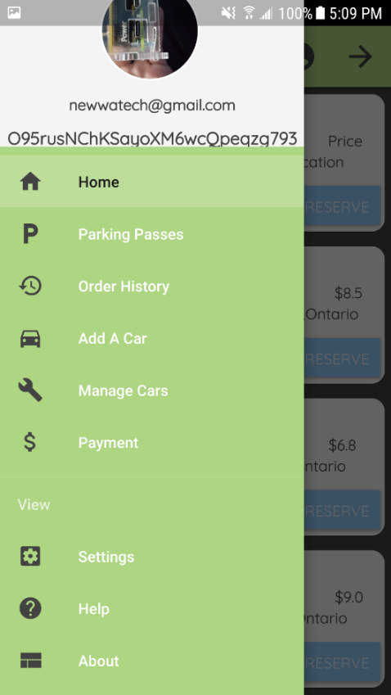

Figure 17 - Main Menu Screen (Sidebar) Figure 18 - Main Menu Screen

In the “Add A Car” screen, the user enters in their vehicle details to register a car to the account. The user is prompted to enter information specific to each account, such as the Make, Model, Color, and License Plate #. We have decided to store each added car into the system and send the data according to a specific user to the database. Once a license plate image is taken on-site of a vehicle, the application will assess this image and try to see if it can match it with the added license plate entered by the user through the mobile application. If the data matches, entry to the lot is allowed and the application would display the gate opening from a visual representation of the lot. This feature is not yet implemented, and will be developed over the current month and finalized by mid-March. There is a button to ADD A CAR, which registers the car to the Firebase database. Once the car is added into the system, and the data is sent to Firebase the consumer can access these details and the registered vehicles in the “Manage Cars” screen.

Manage Cars is where the data is fetched from Firebase database and the information for each “Car” is displayed following a similar format of the main menu. There are 2 options to choose from here: Edit/Delete. Edit allows the user to basically make a change and update the information to the database structure in Firebase. Once the user selects Edit, an inflated view pops up of the fragment prompting to enter in the new information. The user then would tap on the “Apply Changes” button to apply the changes automatically. The changes are visible in real - time through Firebase, once they are set. The Delete option asks the user if they are sure they want to delete the car.If the user approves, the car is deleted from the real-time database and is removed automatically after the next time you access the Manage Cars section. If the latter is chosen, the action is dropped and cancelled to continue the session.

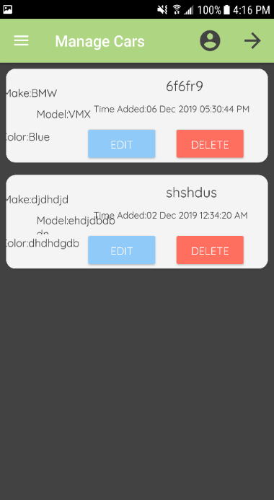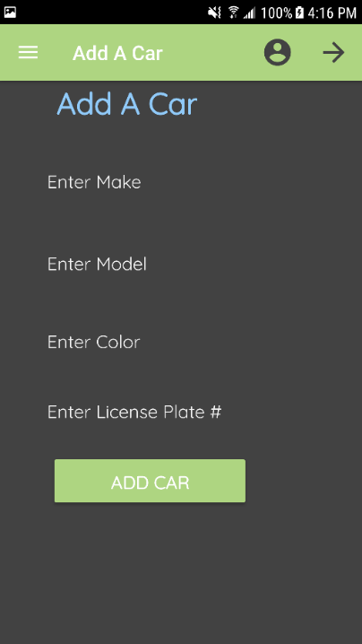

Figure 19 - Add A Car Screen Figure 20 - Manage Your Car Screen

The Parking Passes screen in the application, holds all of the available parking passes for each lot. This includes, the name, location, duration (in hours), validity (time the pass is valid for), type, expiry time, cost, and the account balance before the purchase. There is a button to “SELECT” a parking lot. Once selected the data for that lot is sent to Firebase and stored under the UID of the user. This data is also then sent to the Payment screen, which would be the next step to finalize the reservation through the transaction process.

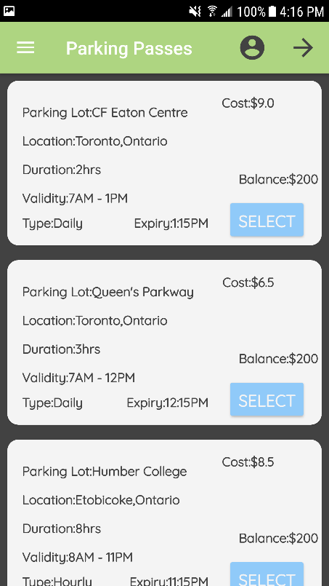

Figure 21 - Parking Passes Screen

On the Payment screen, the selected parking pass is now visible with all the data related to the particular parking lot. On this screen, similar details are displayed, with the addition of an OID (order ID), and e-mail corresponding to the account that is processing the order. Also, the total is calculated for the parking pass with tax and displayed in only a readable form. The balance after the purchase is calculated on the spot and displayed according to the total accumulation. Also, instead of following a credit card method which can be risky in terms of storing sensitive data. Such as, password details or sending data to an online database system. Instead we decided to implement a QR Code generator. The total would be calculated and based on this set value, the “Generate QR Code” button generates a random QR Code using this value. The user would then tap on the FAB (floating action button) which asks to confirm the purchase. If the order is confirmed then it is successfully been processed. A toast message appears saying “Order has been successfully placed! Please View Order History for more details”.

Order History displays the order’s that have been placed using a unique OID (order id) which is the UID used to refer to a specific account. The data is retrieved from Firebase displaying the processed information and a timestamp for when the order confirmation took place.

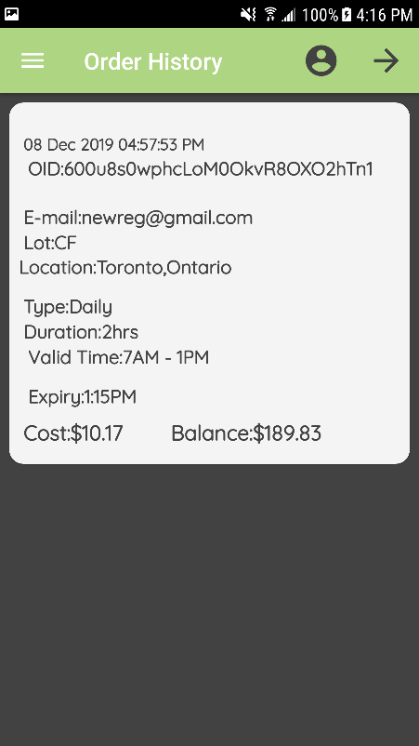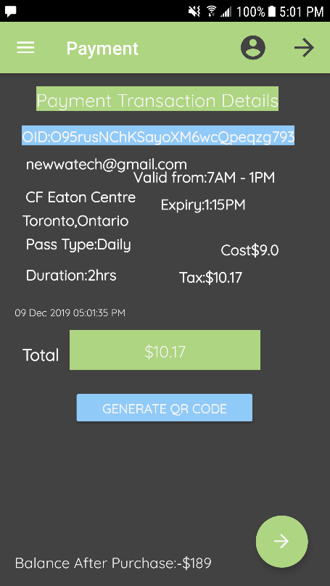

Figure 22 - Payment Screen Figure 23 - Order History Screen

The Setting screen provides a localization feature for (English/French integration). The design basically followed a simple UI, with a button to “Select Language. The user checks which one to perform and the languages change state accordingly without the need of re-entering the app. There may be further features added into the final version of the application, towards the final stages of the project which have not been discussed as of yet. The Help screen, displays general help documentation for ways to navigate to the different screens and use the functionality. The About screen displays project and 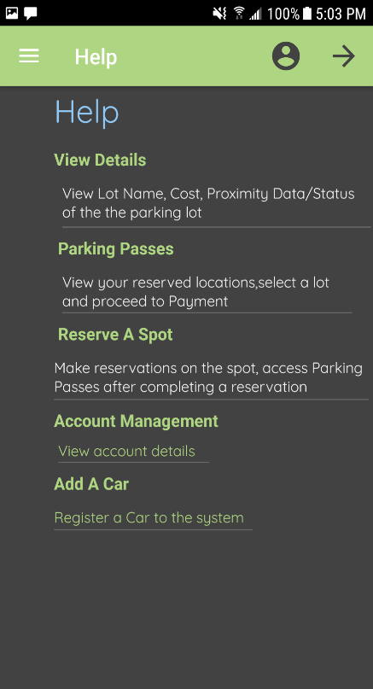general mobile application details.

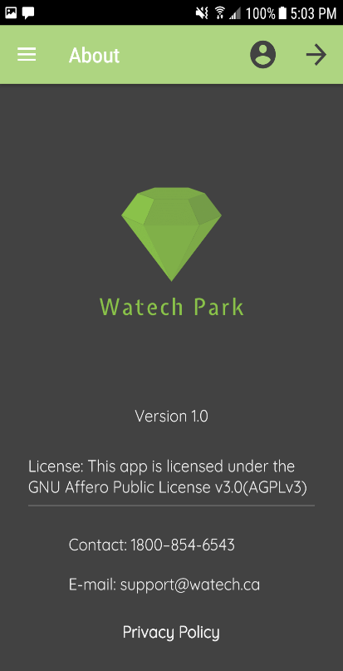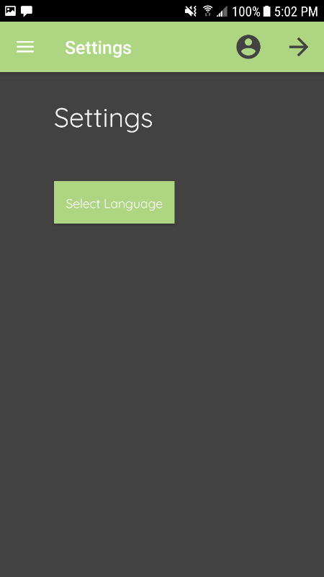

Figure - Setting Screen Figure - Help Screen Figure - About Screen

### Action Control Activity

Hardware used for the project must be controlled in some way. This section will explain this process more clearly and how the hardware sensors/effectors, will be used with the mobile application. Each sensor will communicate with the mobile application for different purposes. To begin, the VCNL4010 Proximity sensor will be used to manage/detect when a vehicle has taken up a parking space in the lot. The sensor will be used in terms of sending/displaying proximity data from how far/near the vehicle is from the spot. This information will then be pushed to the online database, where from the application the user will be able to retrieve this data where it is displayed on the APP. The following is the method of operation for controlling the action committed, once a car has been placed on the parking spot platform, which will be designed/developed during the duration of this semester, the mobile application will detect this change and update the status of the lot in real-time. Therefore, the proximity sensor will only be used to control/detect the distance of an object or vehicle far/near from the actual location. Such as, in a scenario where the parking lot is empty and no cars are visible, the application will relay that data and show all spots “Open” on the application, under a visual manner. A green color will be used along with the RGB LED (red, green, blue) form to accomplish this on the app. In the event, where a vehicle enters the gate and is approaching one of the four spots on-site, the sensors will detect this movement. Then according to this movement, the sensors will know if a car is approaching one of the spots in the location. Our team decided it is best, to only display key data by visually showing the spots in the lot, and only showing which spots are open/occupied or if the lot is full. So, once a car is placed on one of the spots, each proximity sensor on-site will be active, listening and the spot that is taken will update the application to indicate, the spot is currently being occupied(using a red color representation) while all others are in the same state of being open(green). Proximity data/readings will be displayed accordingly based on set conditions, where if a car is approaching and the object is near the sensor the proximity level would be high and therefore the application would indicate an occupied spot. If all spots are taken on-site of the parking lot, then the proximity levels will exceed this amount, therefore the application must display a warning saying “Lot B is Full” and show the remaining spots if any and not allow further entry. This part will be explained further in the Imaging/Firmware branch of this section.

For the IR Break Beam sensor, the main motive behind using this hardware component was to control the gate movements at entry/exit of the parking lot. The sensor will be used to detect when a car is at the gates, and after full validation and error-checking the IR beam sensor will check for an object in the way of the gate. If the car is in the way, the sensor will break the beam and allow the car to enter the parking lot. At exit, the sensor will be used to control the gate as well, to basically allow the car to exit based on distance and movement. Now, once the gates open/close the corresponding data will be sent to the database, and then transferred to the mobile application. This includes, the time of entry, license plate number scanned and the specific UID under which the current user is operating the mobile application. All of this data will be visible for the user, once a specific car assigned to that user has entered/exited the parking lot. On the application, a message will be displayed mentioning “Gate A is opening…” or “Gate A is closing…” once a vehicle is no longer occupying that particular spot, it will return everything to its original state in the data present on the app.

The USB Camera sensor will be used only for the purpose of capturing an image, and license plate recognition. So, once a car comes up to the gates, the primary action to be taken is the camera sensor will automatically capture an image of the license plate, and send this data to the image processing software, and then send it out to the Firebase database. The camera sensor will be placed near the two servo motors and will be the initial action before any decision is made. Depending upon if the license plate image matches with the license plate information stored in the database, entry/exit will be allowed through the two servo motors for that particular user. To allow entry, the license plates must match from on-site of the hardware and the data entered/saved into the mobile application. The mobile application will not store any sort of images of the license plates in any form, but will only be used to track and match the information with the on-site parking lot through the online database.

The two servo motors being used will only act as the barriers between the entry/exit of a vehicle from the gates. This hardware will only be used to control the actual movement of the gates, during entry/exit. Therefore, no preliminary data will be sent through the online database or displayed in any shape or form on the mobile application, as there is no purpose of doing so.

Status

/1 Hardware present?

/1 Memo by student A + How did you make your Mobile Application? (500 words)

/1 Login activity

/1 Data visualization activity

/1 Action control activity

### 

### 3.2.2 Image/firmware

Status

/1 Hardware present?

/1 Memo by student B + How did you make your Image/firmware? (500 words)

/1 Code can be run via serial or remote desktop

/1 Wireless connectivity

/1 Sensor/effector code on repository

### Memo and Initial Setup for Imaging/firmware

In the previous semester, we all had to buy individual Raspberry Pi’s that were all different versions and models. The model of the Raspberry Pi that is being used for this project is a Raspberry Pi 4 Model B. The Raspbian 10 OS had to be installed for the Raspberry Pi 4 used for this project. Raspbian 10 had to be installed on a 16GB MicroSD card that the Raspberry Pi 4 uses to recognize the OS. The recommended size for this project is 16 to 32GB of external memory storage to store all data and sensor functionality with the best performance possible. The file is located online on the Raspberry Pi website on the Downloads page for Raspbian. Raspbian OS can be also installed with NOOBS (New Out of Box Software) which is an easy operating system installer for the Raspbian environment.

Currently, we have developed and integrated code for each sensor to perform specific functions important to our parking application. Along, with having full functionality of the sensors, we also have connected one of the sensors used in the project to the online database, to send/retrieve data from the Pi to the Firebase database.

During this final semester, our focus will be on modifying the current code for each sensor and create a single applicable program to hold all three sensors and their functionalities through the I2C interface. By combining all three sensors into one large program, it will be easier to access the data simultaneously without having the need for separate connections to each sensor, as is what we currently have at this stage of the project. This phase will be targeted and completed as soon as the final PCB design has been finalized and tested for each sensor in early March.

This section was written by George Alexandris (Student B) who is the lead of the Hardware side of the project.

There were two options mentioned one is for installing the Raspbian OS image directly onto the MicroSD to insert in the Pi. The second option is to install NOOBS the easy operation system installer that allows users to select what OS version of Raspbian, and what software is desired to be installed onto the Raspberry Pi. The Raspberry Pi image chosen was the direct install for Raspbian OS. First off, you will have to format the SD card with a FAT32 partition. The next step is to, install the files from the website and extract the files from the zip file downloaded onto the SD card. The SD card is then inserted into the Raspberry Pi. The Raspberry Pi should be setup with the MicroSD card with the image, power adapter for the Raspberry Pi, mouse, keyboard and Micro-HDMI to HDMI cable connected to a TV/monitor. Once you have all these connected to the Pi you can boot the Pi. On bootup you will see a setup wizard and the Raspberry Pi desktop screen.

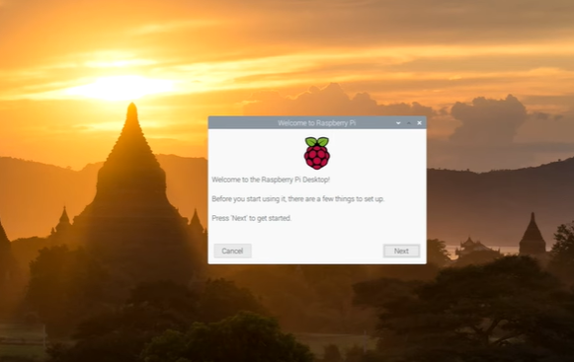

Figure 27: Raspberry Pi Bootup Screen

After bootup, the Pi will show a setup screen to select the language, your location, the keyboard version that is being used. The screen will be shown below. You will have these 3 options shown and when done selecting the options you can click next.

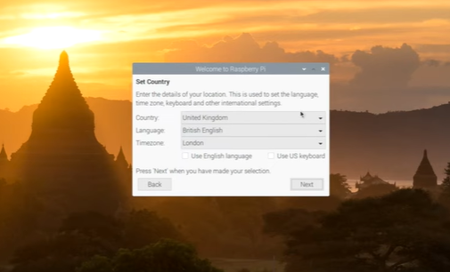

Figure 28: Raspberry Pi Location/ Language setup

After selecting your language and location the user will have to setup the password for the Raspberry Pi. The image is shown below for the password setup. If the user leaves the new password blank the default password is “raspberry” and user is “pi”. The password is then setup and on login the password is required. The pi user is already setup to have all the permissions available. You can also add another user to the Pi after setup. The pi user is a part of a group called “*sudo”*, which this group is basically the superusers of the system. They have access to all commands, files and directories. Raspbian is a version of Linux and uses the Linux kernel for command specific problems. For permissions to files and directories there is 3 permissions for each account. The three permissions are read, write and execute and are assigned to each file for each user, group and other user to access the file. Each user, group and other have permissions on how they can access certain files.

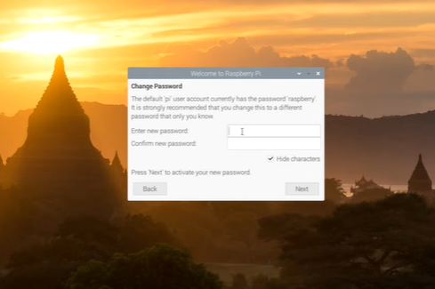

Figure 29: Raspberry Pi Password Setup

### Remote Desktop Connection/Wireless Connectivity

The next step is to setup the network and select the connection through Wi-Fi. Alternatively, the user can connect an ethernet cable to get an internet connection. After the network is either setup wirelessly or wired you will be able to access the computer fully. The Raspbian image is already setup with everything and you can access everything the OS and Pi have to offer.

In order to access the Raspberry Pi wirelessly, you will want to setup VNC server onto the Pi. To setup the Pi VNC server you will have to launch the terminal and type in *“sudo raspi-config”*. A terminal that shows different options to configure the Raspberry Pi will pop up. Control the menu with the arrow keys and select options with the Enter key. Select the option for “Interfacing Options” then another menu will pop up and give you several options to enable/disable the Camera, SSH, VNC, SPI, I2C, Serial, 1-Wire, and Remote GPIO. For this project we needed to enable VNC to use the Pi wirelessly, enable I2C for our sensors to be detected by the Raspberry Pi, and lastly, we activated Remote GPIO to use the General-Purpose Input/output pins for us to connect and to interact with our three sensors for the project. Once each one is selected you will have to reboot your Pi for the options to be enabled.

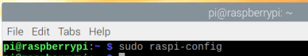

Figure 30: Command to go to Configuration Menu

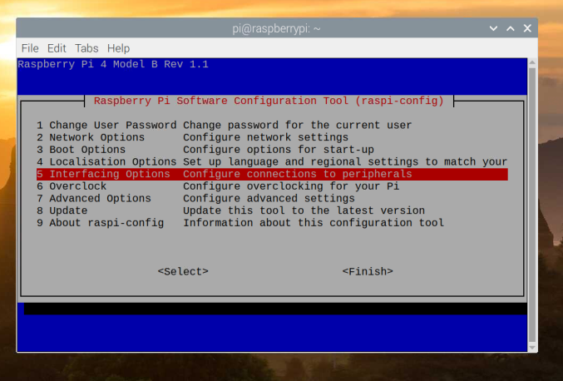

Figure 31: Options after raspi-config command entered to interact with Pi

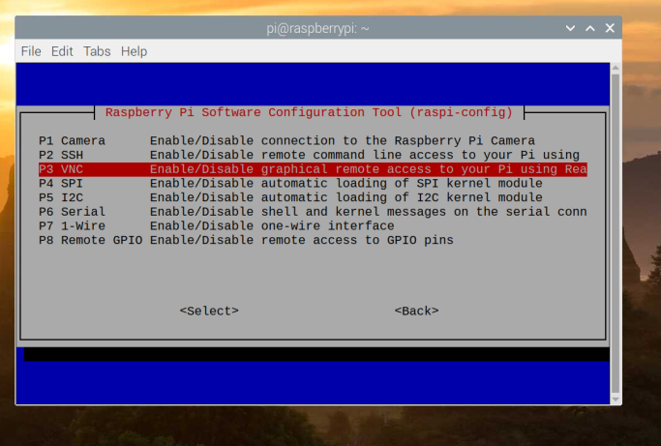

Figure 32: Enable/Disable Pi Interfacing menu

All options to work with the Raspberry Pi and sensors are enabled on the Raspberry Pi. Once the Pi setup is complete, you must download VNC Viewer and create a VNC account online through the VNC website. We used a Windows 10 64-bit version so we had to select that download version of VNC Viewer. Subsequently, once the executable is downloaded, install the VNC Viewer program by running the executable. After the setup of VNC Viewer, on your Windows computer you will have to login to the VNC Viewer and then enter the IP address of the VNC server from the Raspberry Pi.

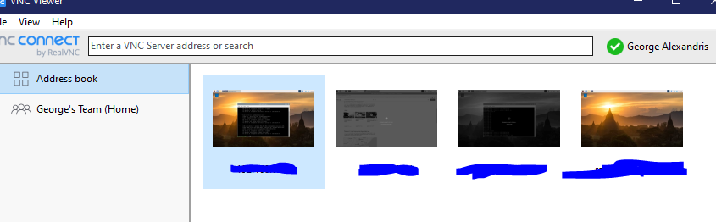

Figure 33: VNC Viewer Main Screen

To find the IP address of the Raspberry Pi you must enter “ifconfig” into the terminal. After the command is entered you will see an IP address near “wlan0” it will have the IP address beside “inet” enter the IP address in the “Enter a VNC server address” field in the VNC Viewer on the Windows computer. Moreover, the Raspberry Pi will be found and will be able to connect to the Raspberry Pi. When you get a connection, a window will pop up to enter the username and password. Enter in the default “pi” username and the password you created after bootup. Finally, you are connected to the Raspberry Pi and you can use your personal computer to control the Raspberry Pi wirelessly.

For the purpose of the code developed for each sensor used in the project, we made use of both the remote desktop connection to connect through Wi-Fi settings, and as mentioned above with an alternate route through an Ethernet connection. The Ethernet connection can be established through use of the VNC Viewer software as described above, by connecting the ethernet cable to the Pi’s LAN (Ethernet port) and to a respective electronics system through the USB port such as a laptop, or PC. In that case, the micro HDM to HDMI cable would not be necessary as the Ethernet connection is all that’s needed to access the Pi and the sensors from any location/setting.

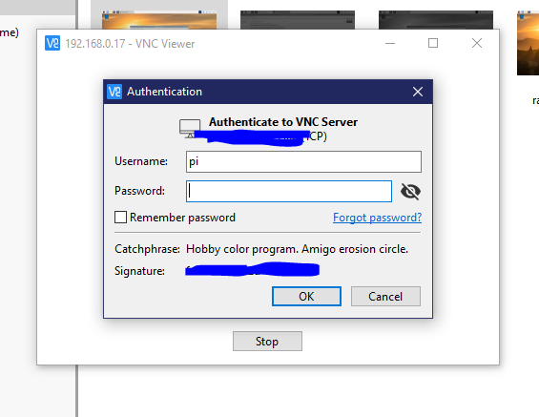

Figure 34: Login Screen to Pi from Windows

Following the login, you will see the Raspberry Pi desktop and are done setting up your Raspberry Pi, and can control it from your Windows computer. At this stage, please remember the Raspberry Pi IP address and login information you made for your Pi to connect to it wirelessly. You can also remove the HDMI, mouse and keyboard you connected to the Pi and you can use your Windows computer peripherals to control it.

The Raspberry Pi was setup for the project like this in this part of the report. The Pi allows us to now connect our sensors to the 40-pin module which provides 3.3/5V power, ground and GPIO pins to control the sensors through coding. We decided to use Python programming to control the sensors from the 40-pin modules.

### I2C Sensor Setup

The sensors we have utilized for this project includes the following: VCNL4010 Proximity Sensor, IR Break Beam Sensor, and the YoLuke’s USB HD Camera Sensor, which all function as expected through the Raspberry Pi platform. The VCNL4010 Proximity sensor is a I2C device, so you will have to go through the setup for the I2C interface for the sensor. As mentioned in the previous section, there is an option in the Raspberry Pi Configuration Tool menu for enabling I2C modules. To do that once again, you will have to type in the command “sudo raspi-config”. Then, select “Interfacing Options” again. The Interfacing Options will be shown for enabling VNC, SSH, Camera, SPI, I2C, Serial, 1-Wire, and Remote GPIO. You will want to enable I2C, confirm to enable the I2C modules. The effect of the I2C modules will start when you reboot your Raspberry Pi, do that by typing in the “sudo reboot” command.

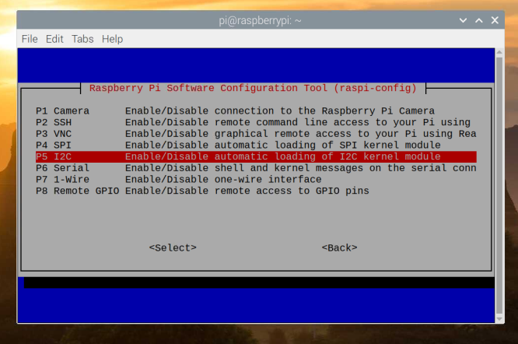

Figure 35: Enabling I2C Module

Once the Raspberry Pi is rebooted it will have enabled the I2C kernel module and you can interact with any I2C device. After reboot, the Raspberry Pi can detect signals from your I2C module/sensor. You connect your I2C sensor and are then able to read the digital signal. First of all, to get the code to interact with your sensor you will have to detect the address of the I2C sensor. To detect the address, you enter in the command “sudo i2cdetect -y 1” into the terminal. After this step, a dump will be outputted for the addresses following this format showing the address being used through the I2C interface, and the which is being communicated with for coding purposes.

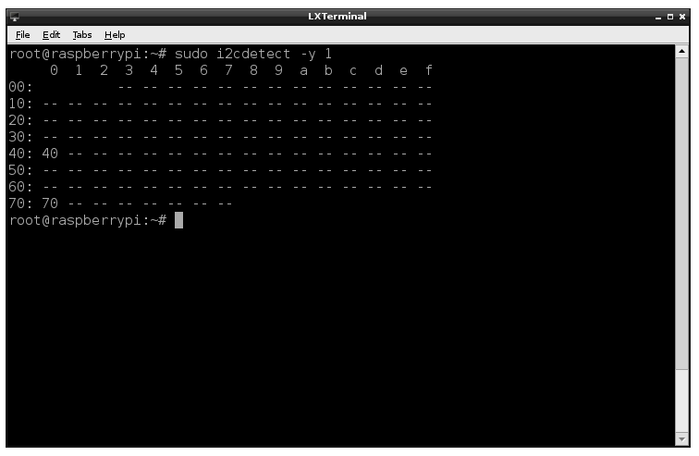

Figure 36: I2C Detect command terminal output

In this case, the two addresses that are going to be in use are 0x40 and 0x70 which will be specified in the code. You will be able to get readings from these addresses by stating them in the code.

### VCNL4010 Proximity Sensor Setup/Code

The VCNL4010 Proximity sensor allows us to detect if an object approaches the sensor, and relays back proximity data in terms of total distance far/near from an object. In our application, it will be used for the parking spots to detect if a car is about to park in a spot, or if a car is already parked in a parking space. The sensor is connected to our Firebase database, which can send and receive values to and from the database. The mobile application also interacts with the proximity data from the database by receiving the sent values from the Raspberry Pi.

The GPIO pins 17, 18 and 27 are used to output values for the sensors in three states, green for an open spot, blue to detect when a car is approaching the spot and red to indicate when a spot is taken. Further details on how the circuit design and implementation will be touched on in the Breadboard/Independent PCB’s section of this report.

The code below shows the strategy that was used to test the hardware + software connection including sending the proximity data to the database and then reading from the data structure *“ProximityData”* and displaying the data on the mobile application.

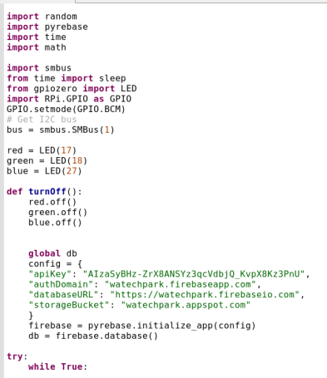

Figure 37: Initial setup for VCNL4010 Python code

The first step required to initialize the firebase configuration, with all the project details. In the code it shows setup for the I2C sensor. The smbus library controls the VCNL4010 sensor. Then, the setup for the GPIO (General Purpose Input/Output) interface is done to control the LED and output and input values for the sensor. This was done through initializing a variable: red, green, blue to store the value of the LED, making use of the three GPIO pins of the Raspberry Pi platform. The “import RPI.GPIO as GPIO” statement was needed to access the GPIO pins on the Pi, and make use of these functions for the LED to process three states, and three separate pins of the Pi as stated above. The time function call was used to allow a delay to occur when necessary in the program, after operation of the sensor is complete of during different changes in states of the LED. A function was also created at this step, to take each value of the LED and turn off the LED after a specific period of time in the code. The function would basically be called later on in the program, to serve its purpose of turning off the LED’s.

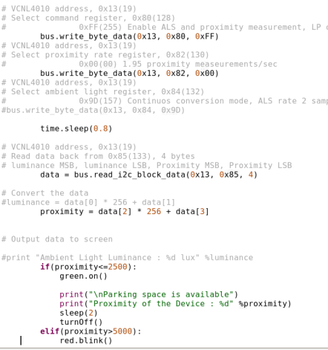

Figure 38: Reading values from VCNL4010 Proximity Sensor

The proximity value from the sensor is taken and used in a while True loop that would print the data while the condition is true. The way this was setup, was based on the different proximity levels of the parking lot at a specific time. The coding aspect was arranged to present different scenarios based on how far/near the vehicle is from the sensor, and basically worked with a range of proximity values. So, if the proximity is less than or equal to a range of 2500, then the green light of the LED will turn on and print a message to say “Parking space is available”, then print the current proximity value, and turn off the led after 2 seconds. At the top as explained before the I2C address was taken from the command “sudo i2cdetect -y 1”. In this case the addresses are 0x13, 0x80, 0x82 and 0x85 to read and write values to and from the sensor.

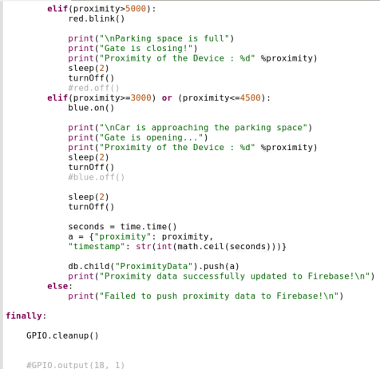

Figure 39: if statements for output of LED color

Then, using an if/else structure to check if the proximity value is greater than 5000 then print out the lot is full, and corresponding data. If it is in the range of 3000 or greater than 4500, display a message saying the “Car is approaching the parking space”. Towards the end of the program, after pushing the data to Firebase the *“GPIO.cleanup()”* function call was used to reset the GPIO pins and basically turn off the LED while not in use.

In the mobile application, how this would work is the data that is sent including the status of the lot would be displayed on the main menu once more details are viewed of the lot. So, while the proximity value changes each time the user chooses a new parking location, the status would also change. On the phone app, it would be indicated by a “Status: Open/Closed/Parked” state. For the purpose of this section, we will only briefly touch on the mobile application integration, as further details have been mentioned previously in the Mobile Application section in this report.

For reference, the code developed for our mobile application for this sensor made use of a original template and was followed and modified to adjust to our parking application, and the overall purpose of the VCNL4010 Proximity sensor in this project. In this case, this template made use of both the proximity/ambient light functions in the sample program, which was not needed for the purpose of our parking application. The template used to support with the coding process can be found here through the following link on GitHub (separate from the project repository) for reference:

<https://github.com/ControlEverythingCommunity/VCNL4010/blob/master/Python/VCNL4010.py>

The code used and developed of the project for the VCNL4010 Proximity sensor can be found here in the project repository address through the “Sensor Specific Code” folder, on GitHub and is denoted by: **vcnl4010_simpletest.py**

<https://github.com/VikasCENG/WatechPark/blob/master/Sensor%20Specific%20Code/vcnl4010_simpletest.py>

### IR Break Beam Sensor Setup/Code

The IR Break Beam sensor in this application, was utilized to detect a vehicle approaching the gate though either entry/exit terminals, through controlling the gate operations of the parking lot. The main focus of the sensor, being to provide status of the lot at different times of a vehicle movement, including the closer a object is to the gate, the more likely the sensor is able to detect the change. In this case, this sensor would be a simple way to basically detect motion at entrance of the lot. The way this works, is through an emitter side, which sends out an IR beam of light, not physically visible. This is done, through use of a receiver and a transmitter. So, when an object/ or vehicle passes by the gate, and is detected by both the transmitter and receiver, and is not reflected back as IR (infrared) light, then the beam is broken and the gate allows entry into the parking lot. More details of how the sensor works with the circuit design itself will be explained in the Breadboard/Independent PCB’s section in this report.

The coding for this sensor was accomplished through the Python programming language. Initially, the design of the code was based on what was needed from our parking application. Therefore, in this case the sensor needed to detect motion of the gate and how far/near a vehicle is from the sensor though emitting an IR beam light, and checking for transparency with a physical object in the way.

The code for the IR Break Beam sensor is simple all you have to do is set the GPIO pin to input and read the output from the output wire from the receiver. The code is shown on the next page.

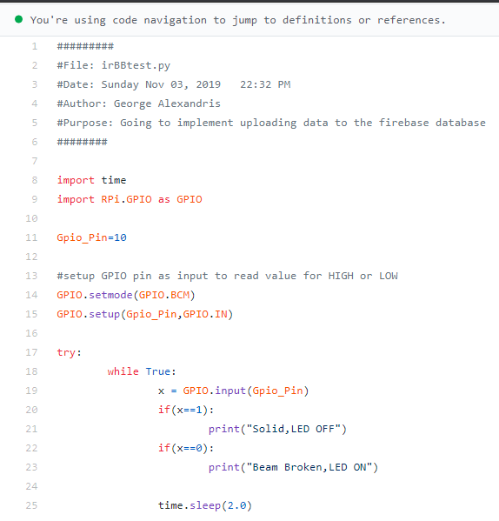

Figure 40: IR Break Beam Python Code

The code reads from the GPIO pin that the receiver output wire is connected to and is set to an input. To set the GPIO pin to input you put in the code *“GPIO.setup(gpio_pin, GPIO.IN)”,* then if you want to read the value of the input you enter *“GPIO.input(gpio_pin)”*. Then to output if the beam is cut I setup two if statements that read if the value is HIGH the beam is received if not the beam is broken.

Initially, on the tests that failed the Python code would send results showing that the pin was in a LOW state and then would change to a HIGH state and stay in the HIGH state forever.

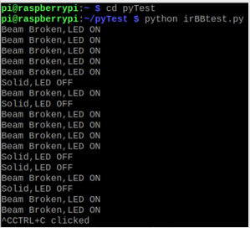Due to the code being set to the wrong pin, the Raspberry Pi was not reading the values from the correct pin. Once the code was set to the right GPIO pin the code was getting the correct values as shown in the screenshot below.

Figure 41: Image of successful IR Break Beam test

The plan for this semester, is to modify the current code for the IR Break Beam sensor to not only detect a vehicle in the way of the gate, but to also update this data to the online database. We had initially decided to not have the gate entry/exit statuses being uploaded to the Firebase database, but considering our application and what we are seeking to develop, we also believe our users would desire to be informed on the status of the gate through different scenarios in the parking lot. Due to this, the current code for this sensor will be modified to send the data, for when the LED is off or when the beam is broken(object passes by the sensor) the status of the lot would be denoted by a 1 or 0 (false) or (true) Boolean condition through the Python coding platform. Following these conditions, the status of the lot would be updated each time an entry/exit is made in the lot on Firebase indicating a corresponding message, and that data would then be presented to the user through the mobile application. This part for the sensor and the coding has not been developed yet and will also be the focus in the upcoming weeks along with modifying the current code structures for each sensor.

The code used for the IR Break Beam sensor for this project can be found in the following link to the project repository on GitHub and is denoted by: **irBBtest.py**

<https://github.com/VikasCENG/WatechPark/blob/master/Sensor%20Specific%20Code/irBBtest.py>

### YoLuke USB Camera Sensor Setup/Code

The camera is setup through a USB port on the Raspberry Pi. You must download a command to make the camera take pictures it is called *“fswebcam”*. To install the program and command you must go to the terminal and type in this command *“sudo apt install fswebcam”*. Then, you must add your user to the video group using this command *“sudo usermod -a -G video <username>”* in order to avoid permission errors. To take a picture of an image you enter *“fswebcam <imageName>.jpg”*. Th program will create the file in the current working directory you are in. You can view it by finding it in the directory. You can adjust the resolution, skip frames, and perform other functions to take better pictures based on overall quality and enhancement.

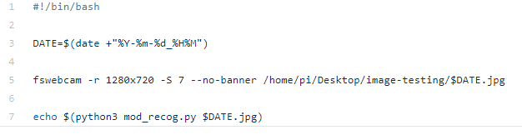

Figure 42: carsnaptest.sh file

This is a file to take a picture with the *“fswebcam”* command with options for setting the resolution to 1280x720. Skipping 7 frames in the command, setting the banner to not show. Lastly, in the *“fswebcam”* command it places the image file to the desktop pi in a directory called image-testing. The image file name is set to the current date and time. Then the on line 7, the last line, it runs an echo command to run a file called mod_recog.py inserting the name of the file in the second argument. The Python program acts as our license plate recognition software.

The contents of the mod_recog.py file will be shown and explained in this part of the report. The screenshot below displays the Camera sensor setup through the python coding environment:

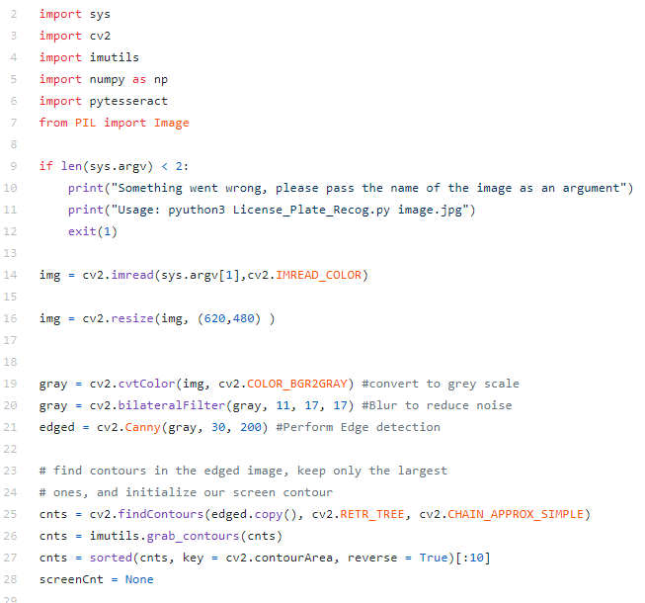

Figure 43: Camera Python Setup

This code is for identifying a license plate number from an image. The code above just sets the variables to recognize colors, the contours and isolate the license plate.

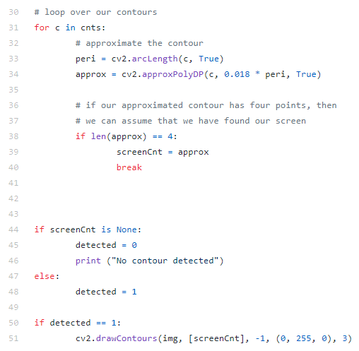

Figure 44: For loop to set contour edges

The *“for loop”* traces the contour to isolate the license plate number. It will count the points of the contour and set it to variable *“screenCnt”*. If the *“screenCnt”* is not set to a value no contour was not set. Then a Boolean is “detected” and the value is set to 0 if no contour is detected, and if it was detected then the Boolean value will equal 1. It will draw the contour in the image and highlight the area of the license plate. The purpose of the sensor for our parking application, is to through the use of the image processing software be able to target and only pick out the contents of the license plate number, excluding any other unnecessary details.

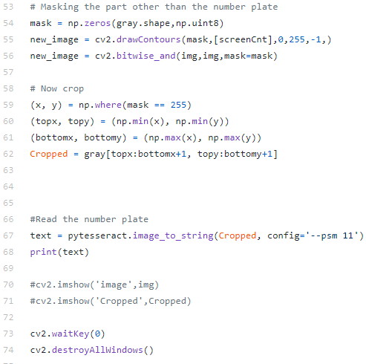

Figure 45: Code to crop and read image

In the code above it will draw the contour edges and highlight the image. Then it will crop at the highlighted contours. After it will read the image plate, and set it to a variable “text” and print the value of variable “text”.

The following is the code used for the project purposes for the YoLuke USB HD Camera sensor, and can be found in the following project repository address through GitHub and is denoted by: **Licence_Plate_Recog.py**

<https://github.com/VikasCENG/WatechPark/blob/master/Sensor%20Specific%20Code/Camera/image-testing/License_Plate_Recog.py>

Other testing phases of the camera senor, including captured screenshots and testing results can be found in the “Sensor Specific Code” folder on the repository and accessed through the **Camera/image-testing** folder branched within this folder.

### PCA9685 Servo-LED Controller Setup/Code

The servo-motor setup is for gate control and are controlled from the PCA9685 chip. The PCA9685 also made use of python code as well in this project to control the servo motors for the gate. The PCA9685 servo driver can control up to 16 servomotors but we will only use 2 for gate control. The PCA9685 driver makes it a lot easier for the Raspberry Pi to communicate and control the servomotors.

To setup control for the servomotors in the Python programming language is simple. The library for the servo-driver can be found in the Arduino IDE library manager. Firstly, to get the library for the servo-driver you need to install the Arduino IDE by typing in the command *“sudo apt install arduino”*. The Arduino IDE allows the Raspberry Pi to easily manage control of Arduino devices.

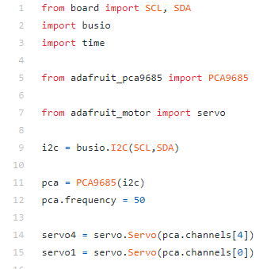

Figure 46: Servomotor Python setup

Initially, in the Arduino IDE you will want to install *“arduino pwm”* library into your code. You can add the library by opening the library manager. Arduino IDE makes it simpler to code the servo-driver to control the servomotors by giving you example code to test the Arduino device. Open the options by going to *“File->Examples->Adafruit_PWMServoDriver”* and select servo, this will automatically add the example code for the servo driver. We used this code as a sample program to test the servomotors compatibility with the servo-driver. Further functionality for the servo-motors, including adding the actual code and implementation of the servo motors with the parking lot prototype model developed will be the main focus for the work of this sensor, to serve its original purpose in the project.

The code used for the PCA9685 servo-LED controller in the project can be found here through our project repository address on GitHub and is denoted by: **servotest1.py**

<https://github.com/VikasCENG/WatechPark/blob/master/Sensor%20Specific%20Code/PCA9685%20Servo-LED%20controller/servotest1.py>

### 3.2.3 Breadboard/Independent PCBs

Status

/1 Hardware present?

/1 Memo by student C + How did you make your hardware? (500 words)

/1 Sensor/effector 1 functional

/1 Sensor/effector 2 functional

/1 Sensor/effector 3 functional

### Memo and Hardware Creation/Design

This section will address the breadboard and independent PCB’s work accomplished throughout the duration of the WatechPark project. This includes, the breadboard /PCB designing, testing phases for each sensor and the progress up to date with each sensor and its overall collaboration with the project. We will be going through each sensor and what led to its initial schematic design, breadboard testing results, and then the PCB which was created for each sensor. Also, including the overall time commitment put into this project for each phase, and the budget accumulated from the final project based on the prototypes developed for each sensor/effector. Initially, the main 3 sensors that will be used in the WatechPark project, were isolated and tested individually by each member of the team, using a breadboard at first and then carrying on with a specific PCB design. The PCB’s were designed separately for each sensor to fulfill the requirements of the last semester, but we are currently working on combining all the sensors into one PCB that will be used in our final prototype. A majority of the work in terms of the breadboard and individual PCB’s (Printed Circuit Board) design process, development phase was achieved through use of the Fritzing software. The Fritzing software is an open-source application that allows the user to be able to create, design schematics from scratch and develop physical circuits on a breadboard, which is replicated through its virtual environment. It is highly customizable and easy to use in terms of its overall appeal. This software allowed each of our sensors to be initially designed from a schematic point of view, and then be able to be tested on a physical breadboard. This was based on the breadboard view on the Fritzing software, which is automatically created within the software based on the schematic design of the circuit. From there, the PCB design was available where most of the connections were made with use of the materials needed to create the PCB’s and follow through with testing each sensor and its functionalities. The PCB work done for each sensor in this project needs to be proceeded with the utmost care and caution, as through our experience we have learned different techniques to avoid any issues that may arise in the development and designing phases. It is advised and important to reassess your design before sending it into the etching and cutting services provided by Humber College, and its prototype lab.

We have also started work on our physical parking lot model which will work with our mobile application and its sensors, to finally display real-time data based on the occurrences of the parking lot, and the state of each sensor on-site. This will be done through the final PCB integration, and testing of each sensor and its functionalities.

All PCB designs used in this project, Figure 51-52,56, were based on datasheets provided by Adafruit (Adafruit Explore & Learn, 2019), we then built the breadboard layouts using Fritzing, Figure 48,55,60, and then finally assembled and tested each design to ensure successful testing and retrieval of the expected outcomes based on the results of each sensor.

Student C (Elias Sabbagh) will be addressing the breadboard/independent PCB’s status of the hardware side in this section of the report.

### VCNL4010 Proximity Sensor Functional

The VCNL4010 is a proximity sensor that utilizes the i2C interface, with a flexible power input between 3.3V – 5V (Adafruit Explore & Learn, 2019), which is perfect because our Raspberry Pi uses 3.3V to handle communication on its i2C interface. Thus, eliminating the need for any voltage controlling parts that would’ve been necessary between the sensor and the Raspberry Pi if we were forced to use any voltage above 3.3V. Another advantage for using the i2C interface, is that all pins used for this sensor can be extended and used with other i2C devices which would make the final joined PCB a lot simpler.

This is the schematic design which was created for the circuit using the Fritzing software. The design below shows the basic pin-outs used for the sensor. There are 6 pin connections and 4 of the 6 will be used (VIN, GND, SCL SDA). The design shows that there is a sensor in the center utilizing a tri color LED on the side. The sensor is connected to GPIO pins 2 and 3 for SDA and SCL of the Raspberry Pi. VIN of the sensor connects to the 5V GPIO pin on the PI. Ground of the sensor connects to GND on the PI. The 2nd lead of the RGB LED (Common Anode pin) connects to 5V GPIO pin on PI. R1(Resistor 1) connects to GPIO pin 17 of PI, R2 to GPIO pin 18 of PI, R3 to GPIO pin 27 of PI. The tri color LED is connected to ground, then GPIO pins 17, 18 and 27 to output values for the sensors in three states, green for an open spot, blue to indicate when a car is approaching one of the spots and red for when the spot is taken.

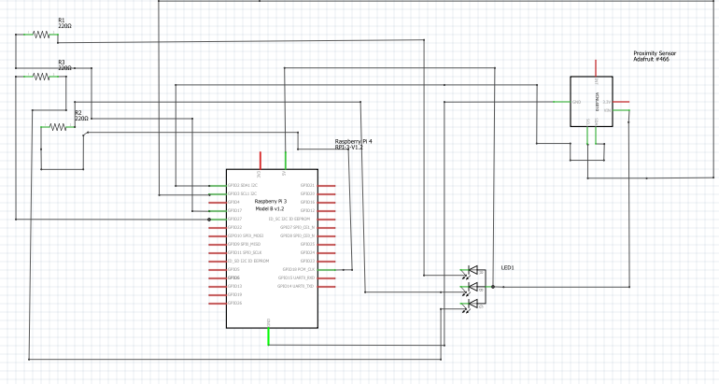

Figure 47: Fritzing Schematic design for VCNL4010 Proximity Sensor

The breadboard testing portion required to test the circuitry if it responds to the sensor and if the RPI can detect the sensor and its i2C interface. Using the Fritzing software, here we basically transferred the schematic design to the breadboard. I followed the breadboard design on Fritzing for the circuit, with use of 11 jumper wires. For this sensor, we then decided to use the 5V GPIO pin, designing a voltage divider circuit in the process. This is to ensure there is no possible damage to the circuit, with the amount of current being supplied to the circuit. Based on the breadboard design the sensor used 3.3V out of the 5V which was leftover voltage after the 1st resistor (5V – 1.7V = 3.3V). The voltage was divided between the 3 220-ohm resistors, using roughly 1.7V out of the 5V. The following is the breadboard design created through the Fritzing software.

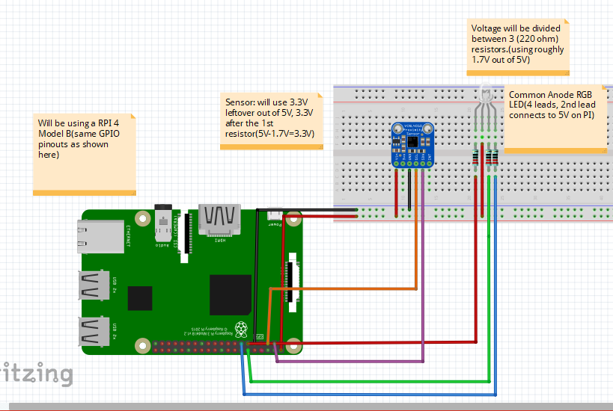

Figure 48: Fritzing Breadboard design for VCNL4010 Proximity Sensor

After the breadboard design has been laid out, the next step was to build the actual circuit on a physical breadboard as shown below which show the connections to each part of the sensor and it’s accompanying parts.

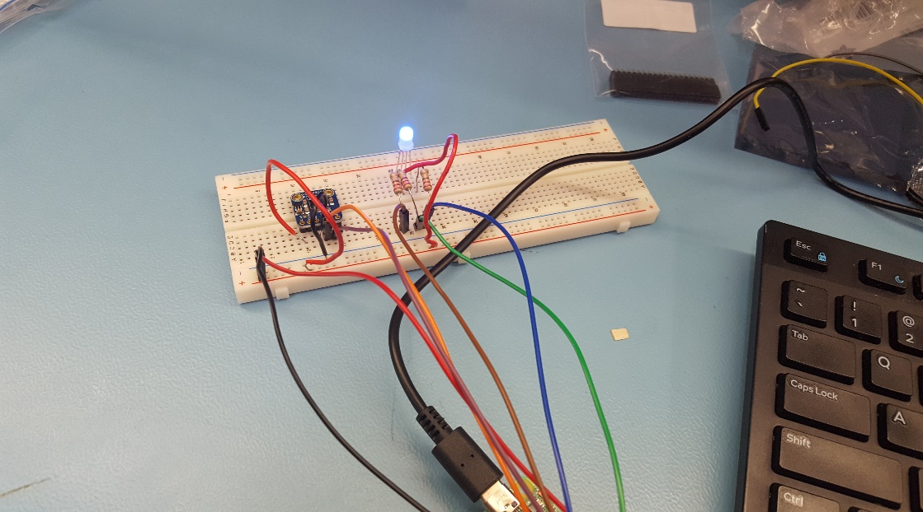

Figure 49: Breadboard design for VCNL4010 Proximity Sensor

To test the breadboard circuit, we first had to check if the sensor was working as needed with the design. The sensor uses an i2c interface, so we tested using the following command *“sudo i2cdetect -y 1”* to detect if it works and if the i2c connection has been made as shown in the screenshot below:

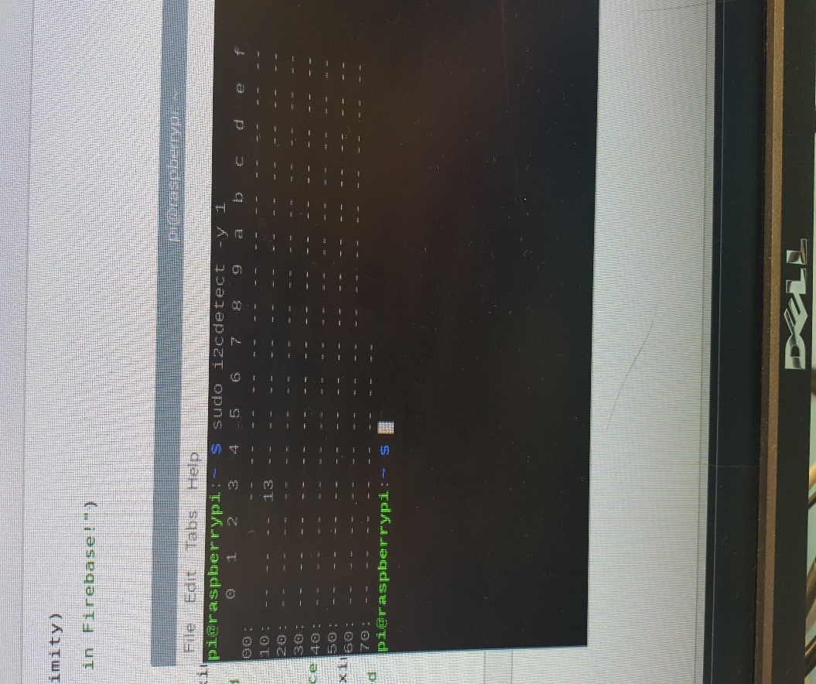

10

Figure 50: I2C testing results for VCNL4010 Proximity Sensor

Using this command, you can see the sensor is reading the bytes of data from the i2c interface on address 0x13, showing successful connection of the sensor to the breadboard design.

The next step was to design the PCB board. During this process, we ran into many problems trying to get the right design down, as the board required many changes. The main point being the positioning of the top/bottom layers. After much consideration we were able to successfully complete the PCB design. This is because, all the connections that go to the GPIO pins had to be in the top layer, and there must be no overlapping connections between the top/bottom layers. So, after redesigning the board, we had to rearrange the top/bottom layers and from there we were able to complete the PCB design as needed. After getting the PCB design finalized, we sent it into the prototype lab to be produced using the laser-cutting services provided, through our tuition.

To solder the PCB board, you would require a lot of focus, and attention, because any accidental procedures/connections going wrong can cause you to redesign the whole board. We were able to luckily not have to go through that process, while soldering. For this sensor design, there were 4 vias that needed to be soldered. You must thread a single thin wire through the holes, solder it and then cut off the remaining excess wires. The same process, was taken for the resistors where we set up the resistors in their place and had to solder the 2 sides. Then, cut off the excess wire. While soldering the LED, we had to be very cautious as the connections were designed really close to each other, so a lot of focus was needed here. Initially, there is a 6-pin header that comes with the sensor that needed to be soldered. Also soldered was, the 40 pin GPIO pins on the PI, to keep the header stable while soldering. The screenshot shown on the right below shows the Fritzing design of the PCB and the end design which was sent into for cutting service to be produced. After soldering, the board should be ready to be tested, and should look like the screenshot shown on the right below.

 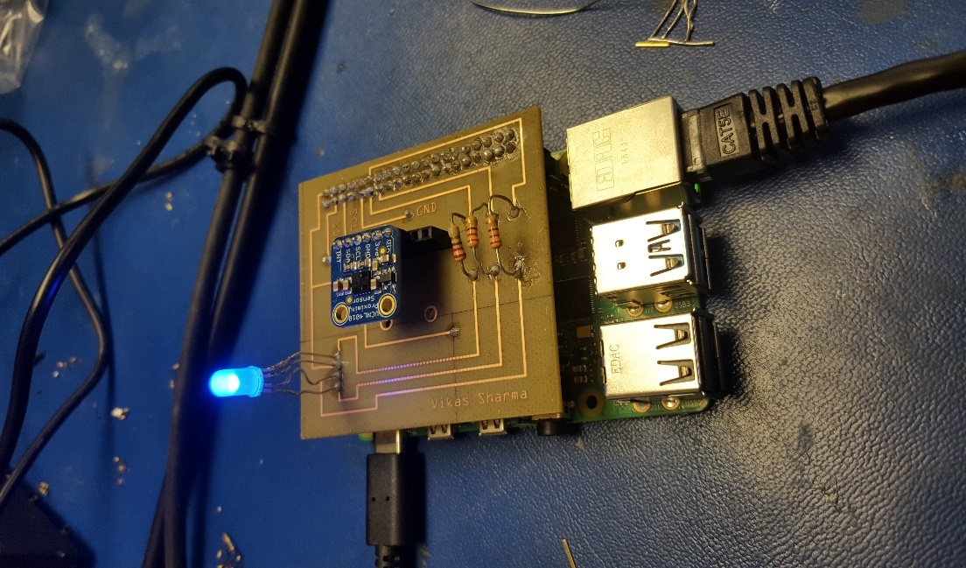

Figure 51: Fritzing PCB design for VCNL4010 Figure 52: VCNL printed PCB Final Design

To test the connections and the functionality, we added an LED to confirm power delivery to the sensor, and tested the functionality by covering the sensor with a piece of paper by reading the values through a testing script on our Raspberry Pi. Next, we tested if the LED functioned as designed for testing purposes. After setting up the circuit, and running the python program created for the sensor and its main application, we were able to get the LED working and tested different values based on the purpose of the sensor in our parking application. We played around with the code by testing different colors to see if we can get all three values of red, green, blue to blink/flash which we were able to do successfully. Using if/else statements to see if the LED can communicate with the PCB board and the sensor, which we were successfully able to do as shown in the screenshot captured below.

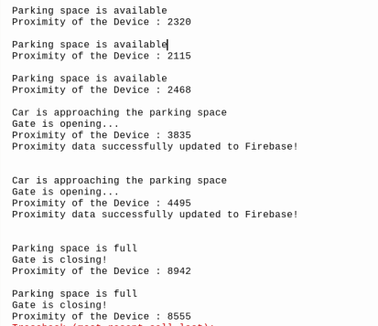

Figure 53: Breadboard/PCB Testing Results for VCNL4010 Proximity Sensor

### IR Break Beam Sensor Functional

This is an analog type of sensor that is split into two parts for it to do its job. This meant that we needed to utilize 3 pins on our Raspberry Pi to use it, 2 pins for power delivery and 1 pin for the analog signal to be read when the IR beam is cut off by an approaching vehicle. Based on the datasheet (Adafruit Explore & Learn, 2019), this meant that there is no need for any additional parts like resistors or transistors to drive this sensor when tested by itself.

The IR Break Beam sensor has two parts to it one the receiver and transmitter. The transmitter part has two wires one for power and the other for ground. Both wires on the transmitter part of the IR break beam sensor can directly connect to power and ground without resistance. The receiver has 3 wires power and ground as well similar to the transmitter part, but the third wire is a digital output. The power and ground are both directly connected to the power and ground on the Pi. Both parts (receiver and transmitter) of the IR Break Beam sensor each have power and ground, and either can be connected to 3.3V power or 5V power. If the transmitter is connected to the 3.3V it offers shorter range for the Infrared beam to travel but if you connect it to 5V you can send the beam farther. To be safe and to avoid any damage, for the sake of this project both parts of the IR break beam were connected to 3.3V. On the receiver side of the IR Break Beam, the output wire must be connected to a pull-up resistor to read the digital signal. A pull-up resistor of 4.7K Ohm is required, connected to VCC to ensure the known state for a signal. Just like the VCNL4010, we connected an LED and a resistor with the IR break beam sensor to confirm power delivery, and to test functionality we blocked the connection between the sender and the receiver parts of the sensor with an object, and then read the value on the logic output on both the Raspberry Pi and an external multimeter. This LED emits a red light when powered on, it requires a 1K ohm resistor to be lit up to control the voltage and current levels going into it. When the output wire sends the digital signal, it turns on the LED. The LED is used to indicate if the beam is detected or not by the IR sensor. The schematic design for the IR Break Beam will be shown below, produced through the Fritzing software.

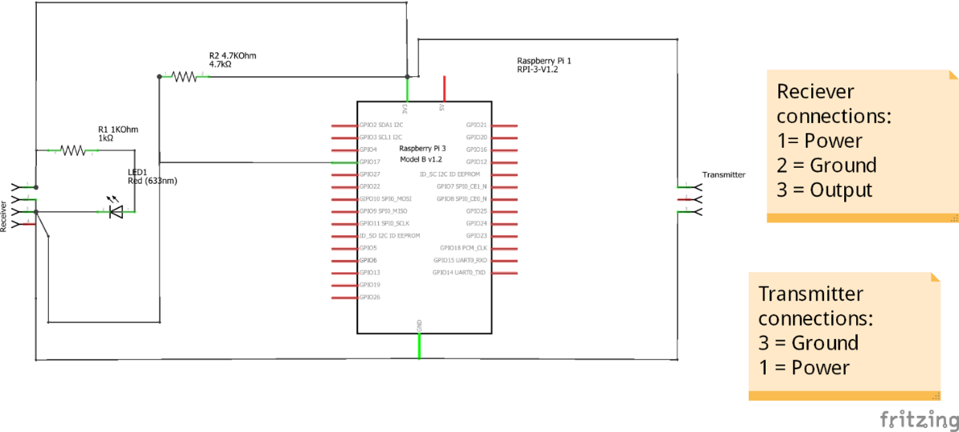

Figure 54: Fritzing Schematic design for IR Break Beam Sensor

The following screenshot below is the breadboard design, built based on the schematic design using the Fritzing software. It displays all of the physical connections needed for the sensor to function and operate as needed, and to meet the requirements of starting the development of the PCB for the sensor.

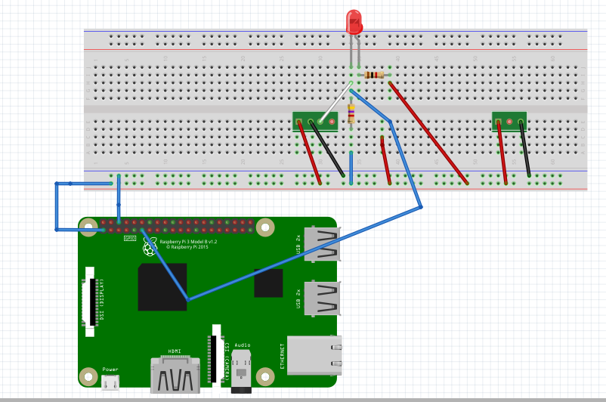

Figure 55: Fritzing Breadboard design for IR Break Beam Sensor

The PCB designs were all created in a free software called Fritzing as mentioned above. All designs were done in the application from the breadboard design, schematic and then the PCB. The PCB was completed last in the design process. This is to make sure the breadboard tests go well and to see if there can anything being read from the sensor. After the breadboard design and testing is completed, the PCB design needs to be finished. The final PCB design shown here below is made to represent something similar to the breadboard design. Transmitter is connected to both 3.3V power and ground, and the receiver is connected to 3.3V and ground directly, and then its output wire is connected to a 4.7k ohm pull up resistor, LED and then to another pull up resistor that is 1k ohm, also mentioned above. Then the third line from the output wire is connected to the GPIO pin 17.

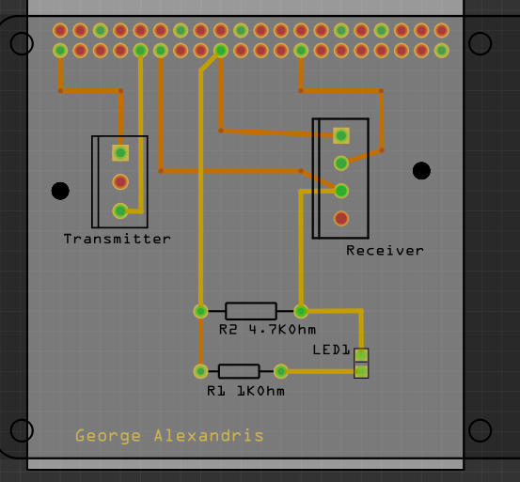

Figure 56: Fritzing PCB design for IR Break Beam Sensor

Breadboard testing for the IR Break Beam sensor came from a few different designs, more generally from testing different designs specified from sources. Some were failures and some were generally fault in the code, second guessing the design of the circuit. The testing of the breadboard circuit came from multiple designs just to see if a digital signal can be read from the receiver to the Raspberry Pi’s GPIO pins. Some of the designs were faulty due to the code that was tested, or some the pins were not reading the right signal. On the tests that failed, the Python code would send results showing that the pin was in LOW state and then would change to HIGH state and stay in the HIGH state forever. The following screenshot shows the unsuccessful testing of the sensor, which will then be followed up in the next image with the successful testing outcome.

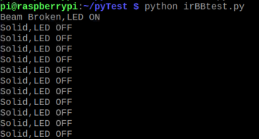

Figure 57: Image of Failed Breadboard Test of IR Break Beam Test

Due to the code being set to the wrong pin, the Raspberry Pi was not reading the values from the correct pin. Once the code was set to the right GPIO pin the code was getting the correct values as shown in the screenshot below, showing successful testing of the breadboard/PCB portion for this sensor and its functionalities.



Figure 58: Image of successful IR Break Beam test

### PCA9685 Servo and RGB LED Controller Functional

Just like the VCNL4010, the PCA9685 utilizes the i2C interface and has a flexible voltage input range, additionally, it also has a built-in LED indicator that lights up when the controller is powered on, therefore simplifying not only the breadboard testing design, but the final PCB design as well.

Given that the PCA9685 is a 16-channel servo/PWM controller, an additional external power source is needed to avoid overloading the Raspberry Pi when supplying power to the servo motors and the LEDs. This external power source can be connected directly to the PCA9685 using an isolated power and ground pins. Once the PCA9685 has been powered and connected through the i2C bus, a simple python script can detect it and test its functionality by controlling connected servo motors or changing the color of an RGB LED. The following screenshot below shows the design and development of the schematic design used for the circuit.

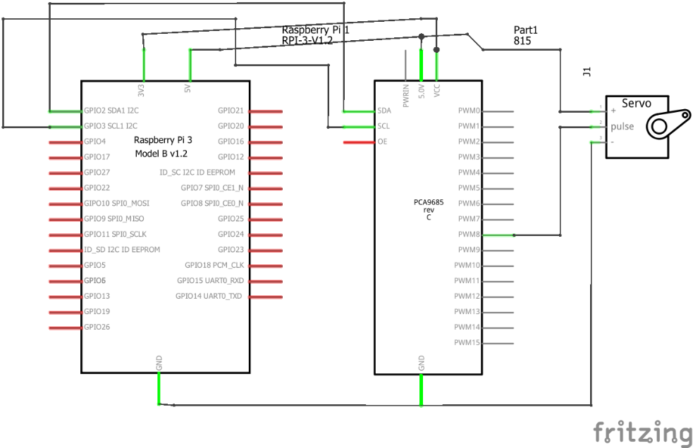

Figure 59: PCA9685 Fritzing Schematic Design

After designing the schematic layout of the circuit, the breadboard design was developed through the Fritzing software as shown below.

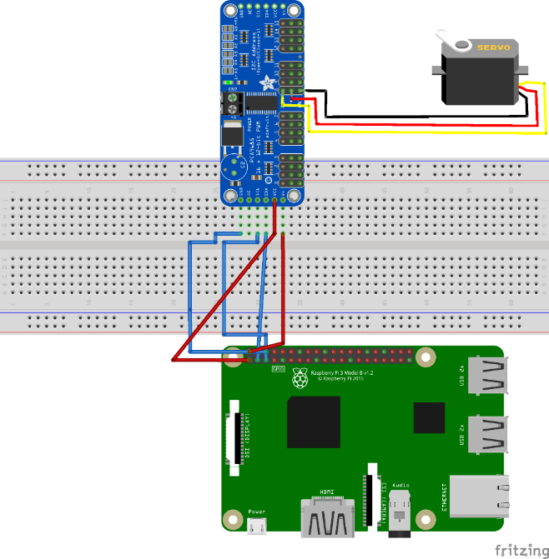

Figure 60: PCA9685 Fritzing Breadboard Design

Due to the time commitments of this semester, our team decided it was best to not develop a PCB board for this individual sensor/effector and instead go straight to the final PCB design. At this stage of the project, the final PCB is currently being designed and finalized. The individual PCB was not developed for this sensor in the previous semester, as this is a new addition to the project, using a separate controller to hold the RGB LED’s and their functions in the project, as well as to control the 2 servo motors used in this application. The use of this controller will help reduce the total voltage supplied to the Raspberry Pi through all 3 sensors, and will avoid any potential damage. As for this PCB design finally, we will make use of only 3.3V of the PI, and reduce the amount of current being used which is a maximum of 50mA, which we believe will be enough to support our project and its sensors.

For the YoLuke USB Camera sensor, a breadboard and PCB design were not needed as the sensor requires a USB connection to the Broadcom Development Platform only, being to the Raspberry Pi itself. We had initially planned to integrate a potential USB connection on the final PCB design, but that idea was re-assessed and eliminated as the VCNL4010 and PCA9685 only needs a I2C interface and connection. The only difference comes from the IR Break Beam sensor, where it utilizes a SPI interface instead. When building the earlier prototypes, our aim was to test each sensor and effector individually before combining them all together and testing their functionality once joined.

In regards to our time and progress, we have been perfectly in line with our critical path, and have assembled a breadboard to test the connections of our final PCB before sending it to the prototype lab to be printed, once the PCB has been tested and finalized. We will work on the housing case that will be fit onto our custom parking lot design once each sensor and its accompanying functionalities have been established and thoroughly tested. This will be done through both the hardware and mobile application side of the project, with the main focus being the final PCB design and completion in the next phase of the project.

The VCNL4010 Proximity sensor will be used for the 4 valid parking spots on our parking lot system prototype model, which is currently being developed. Therefore, we will make use of an additional 3 VCNL4010 Proximity sensors and extra 3-4 RGB LED’s to fulfil the requirements of our project towards the end of the semester. The total amount for this final semester alone, will be $261.79 including only the materials needed for the duration of this semester. Here’s our current accumulation in a Bill of Materials format.

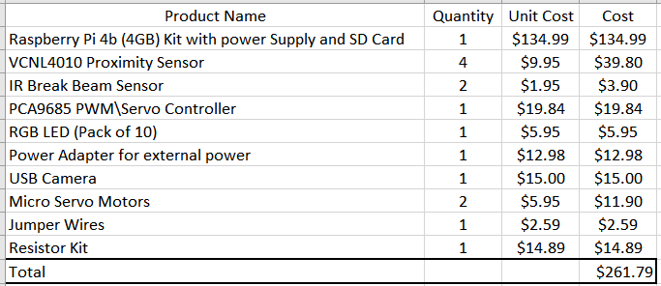

Figure 61: Bill of Materials

### 3.2.4 Printed Circuit Board

Demo

/1 Hardware present?

/1 PCB Complete and correct

/1 PCB Soldered wire visible but trim, no holes or vacancies

/1 PCB Tested with multimeter

/1 PCB Powered up

How did you build your Prototype: PCB?

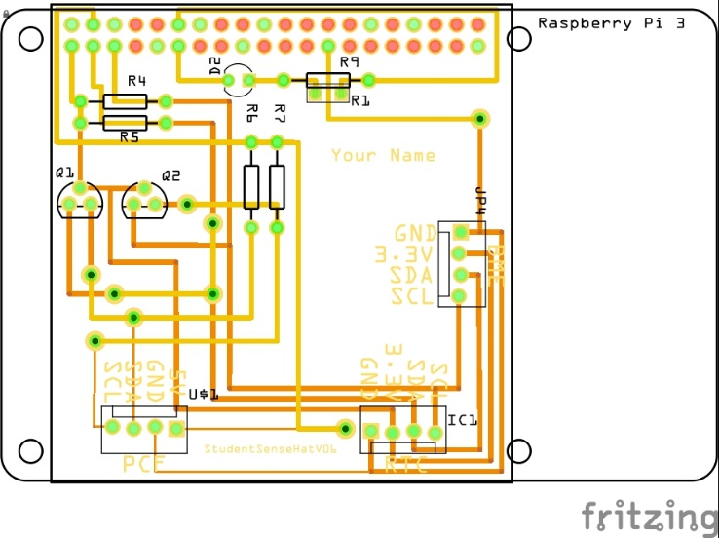

Figure 5. PCB design This work is a derivative of "http://fritzing.org/parts/" by Fritzing, used under CC:BY-SA 3.0.

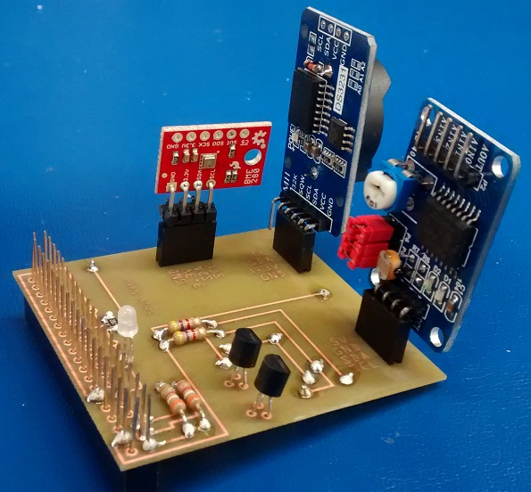

Figure 6. Humber Sense Hat Prototype PCB.

### 3.2.5 Enclosure

Demo

/1 Hardware present?

/1 Case encloses development platform and custom PCB.

/1 Appropriate parts securely attached.

/1 Appropriate parts accessible.

/1 Design file in repository, photo in report.

How did you build your Prototype: Case?

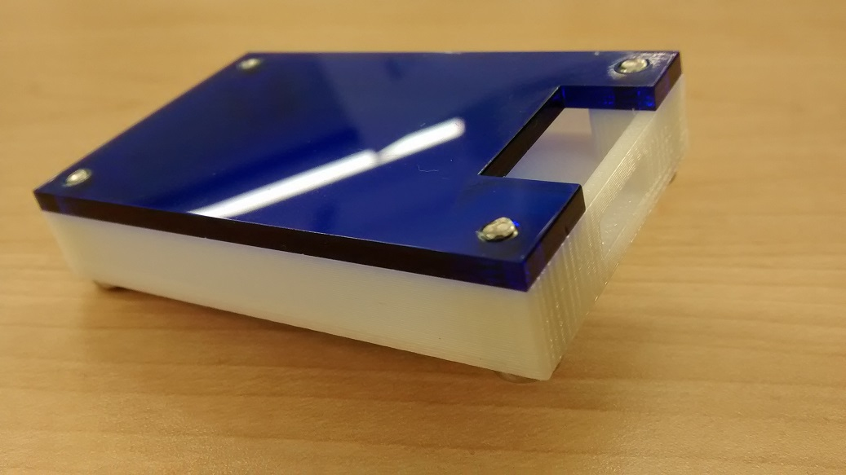

Figure . Example enclosure.

## 3.3 Integration

Demo

/1 Hardware present?

/1 Data sent by hardware

/1 Data retrieved by mobile application

/1 Action initiated by mobile application

/1 Action recieved by hardware

Report

/1 Enterprise wireless connectivity (250)

/1 Database configuration (250 words)

/1 Security considerations (500 words)

/1 Unit testing (900 words)

/1 Production testing (100 words)

### 3.3.1 Enterprise Wireless Connectivity

How did you make a Database accessible by both your Prototype and Mobile Application?

### 3.3.2 Database Configuration

### 3.3.3 Security

### 3.3.4 Testing

Unit testing and Production testing.

# 4.0 Results and Discussions

Is your prototype perfect? What did you learn?

# 5.0 Conclusions

If you were making 1000 of these.

Report

/1 Hardware present?

/1 Checklist truthful

/1 Valid Comments

/1 Results and Discussion (500 words)

/1 Conclusion

# 6.0 References

*EasyPark*. (2016). Retrieved from EasyPark Mobile Parking App: https://www.easypark.ca/products-services/mobile-parking-app

*EasyPark*. (2016). Retrieved from City Parking Vancouver, Public Parking, EasyPark Mission: https://www.easypark.ca/about-easypark/mission

*EasyPark*. (2016). Retrieved from History: https://www.easypark.ca/about-easypark/history

*Google Play*. (2020). Retrieved from EasyPark Parking - Apps on Google Play: https://play.google.com/store/apps/details?id=ca.easypark2.app&hl=en

Park Indigo Canada Inc. (2019). Indigo. Retrieved from https://ca.parkindigo.com/en

ParkWhiz. (2019). Find and Book Parking Anywhere. Retrieved from https://www.bestparking.com/

# 7.0 Appendix

## 7.1 Firmware code

This status update will address the firmware code and integration status of the project up to date. This also includes, the financial state of the project, progress accomplished for each specific hardware device and its relating firmware/code. As well as, the modified code files in the Appendix, and then followed up with the link to the complete code to the repository on GitHub. This includes, the final code integration for each sensor/effector utilized in the project into a main central python program,

Demo

/1 Hardware present?

/3 Code runs concurrently for all sensors/effectors

/1 Project repository contains integrated code

Status

/1 Memo including updates

/1 Financial update

/1 Progress update

/1 Modified Code Files in Appendix

/1 Link to Complete Code in Repository

### Memo and Updates

At this stage of the project, we have completed most of our set objectives from the initial designing, development phase of both the hardware and software aspects of our parking application. Currently, we are using this present time to support us with identifying any internal or external issues and find quick, reliable solutions to any problems we may face in the future. In terms of the firmware status for all three sensors being utilized for the project, we are pleased to announce we have successfully integrated each individual sensor into a single program to run all sensors concurrently with each other to display readings, and gather real-time data. This includes, displaying the proximity data from the VCNL4010 Proximity sensor working alongside the IR Break Beam sensor to detect the presence of a vehicle at the gates. The plan in the previous Imaging/Firmware section was to implement this firmware integration in early March, and we have successfully done that through the use of breadboard testing and extensive coding. The firmware is set at this stage for each sensor to provide its functionalities to our application, and corresponding readings to be supported with our online database. This is the next step of the project we are currently working on, to have the mobile application work with the online database through a real-time data retrieval structure. Now, we are able to have each sensor talk to each other depending on our needs and desired outputs from the firmware side of the code, and through successful breadboard testing we can ensure we will be able to complete both the mobile application, and wireless database configuration in the upcoming milestones.

The code finalized at this stage represents all 3 sensors along with their successful integration into one main program. The database configuration has been included into the code provided in the upcoming parts, but due to unfortunate circumstances currently we are unable to have the database connection working with the final firmware code assembled. This issue is in regards, to the VCNL4010 Proximity sensor where once the code for the database was tested and a value based on the level of the proximity is sent to Firebase, due to some unexpected circumstances this caused the program to crash. The issue is being looked at this time, and will be solved with immediate care to ensure we meet all requirements for the project. Due to this reason, we decided it was best to conform with the firmware code we have successfully tested right now for all sensors/effectors, and move to the database connection once we have established and make sure that the integration can be made. This will be focused on for the upcoming week, along with further work on the mobile application will be established.

During the reading week, we used the time to work on the firmware code and complete the final code to be demoed and presented in the week of March 3rd. Although, during this time we also ran into an issue regarding our physical parking lot model prototype and our intended firmware code that was assembled for the project. We found out that the VCNL4010 Proximity sensor only supports a fixed I2C address of 0x13, which means for the intended 4 spots on our parking lot prototype, we would be unable to have each proximity sensor stationed at each parking space to use a unique I2C address. This is because, this value is fixed and therefore cannot be changed in any manner. Due to this issue, our team had to re-assess and think critically based on the options we had available to us. Therefore, we came to a consensus to only have one spot on the parking lot be used with only one VCNL4010 Proximity sensor sending the data from the sensor to the online database, and then displaying the status changes on the mobile application. The remaining spots which include the following: Slot 2B, Slot 3C, Slot 4D will be simulated to a set value of “occupied” in the parking lot at all times. This will reduce the work needed for each spot, and the code will flow much efficiently for all sensors.

Fortunately, this will also allow us to engage into what other features may be applicable or desired to be used by our consumer demographic. It is important to mention, after performing deep research and findings that we also considered a use of the TCA9548A I2C multiplexer device to have each sensor utilize different I2C addresses, allowing access to multiple VCNL4010 devices. Due to time commitments, and our current status of the project we decided to have this be the last option if there is enough time available to us at the end of development of the project.

As a replacement, we decided it was best to move on with only one spot on the parking lot, which is slot 1A and to be accompanied with a single VCNL4010 Proximity sensor to solve the problem. If there is enough time provided at the end of development, the I2C multiplexer may be an extra addition to the project but is not the focus at this time. Another minor change, resulted from the RGB LED use, the 3 Common Anode LED’s were initially planned to be used. Through testing with the servo controller, it was evident to us that the LED’s are using an increased amount of current which may serve as a risk, and potentially blow out one of the LED’s. This caused the color “red” on the LED to produce a very bright appearance even, when turned off/or dimmed. As of right now, we have decided to instead acquire Common Cathode RBG LED’s to reduce the amount of current utilized by the LED’s at each parking space on the parking lot. This in return, will create a much simpler connection to the PCA9685 servo controller using its’s built in resistors to limit the current used for each color (red, green, blue), avoiding the need of any other external connections.

The YoLuke’s USB Camera sensor, required a major change as well due to software issues with testing the image processing software for license plate detection. The intended purpose, was to have the sensor capture a screenshot of the license plate, and have this screenshot go through the image processing software, retrieving the single license plate number details. After much consideration and testing, we were unable to get the software working with the Camera sensor. Due to this reason, we had to come up with an alternative solution that works through simulation of the license plate detection method. Now, when the Camera sensor takes a screenshot of the license plate, instead of having to go through the image processing, we created a function in the firmware/code to store a fixed string value of the license plate number which will be called immediately upon entry. The firmware/code had to be re-adjusted for this reason, and the image processing software code portion was dropped as a result. The Camera sensor code will be added into the final code while the database connection is made and will be tested for the purpose to capture an image of the license plate only.

### Financial Update

As of March 3rd, there has not been a major financial change in the project’s cost. In our current situation and due to time limitation, the use of more than one VNCL4010 sensor has been dropped and thus reducing the overall cost by $22.5 USD, but on the other hand, if we had no time constraints then the original overall cost would’ve been increased by $6.95 USD as we would’ve required a TCA9548A I2C multiplexer board to allow us to communicate with multiple VCNL4010 sensors. We also had to switch from a common anode RGB LEDs to common cathode RGB LEDs, which has a very minor impact on the project financially.

### Progress Update

As we currently stand, the progress for the project is continuing gradually with some challenges due to software limitations. Development is progressing from the hardware and software side, with minimal changes to overcome. These changes had to be re-evaluated for long-term benefits in relation to the original goal of the project, and whether certain features/parts were needed or unnecessary in different scenarios. The final code right now represents the three sensors running and reacting to changes in the parking lot, and will be coupled with the mobile application and online database in the following 1-2 weeks. The code right now utilizes each sensor and provides it’s intended functionality through our application. This includes, the initialization for all 3 sensors/effectors, and since each hardware type is a I2C device the code assembled for the firmware was modified to be much simpler, and effective. The IR Break Beam sensor and the VCNL4010 Proximity sensor work together at the same time, rather than the planned implementation of having each part of the code work in a sequence. Now, the VCNL4010 Proximity sensor does not have to wait for an excess amount of time as it runs concurrently with the IR Break Beam sensor. The code segment for the IR Break Beam is now fully functional with the entry/exit scenarios, based on the status of the gate. The servo motor code has also been integrated into the code for the PCA9685 for both entry and exit situations on the physical parking lot, to move the motors up and down in a 90 degrees rotation. The firmware/code for this sensor will also work with the IR Break Beam sensor to sense the opening/closing of the gates. These functions developed for this sensor will be called in the code, once the database connection has been fully established later on.

Our primary focus in the upcoming final weeks of the semester, will be to complete the mobile application integration along with the wireless database configuration/connection with having the firmware thoroughly tested. The code will then be tested with the final PCB design and tweaked based on any changes we may feel need to be adjusted. Currently, the final PCB design has been sent to the prototype lab to be etched and produced and our plan is to solder, and test the final code of the firmware over this upcoming weekend, for each sensor with the board. Further details on the final PCB integration is described in the PCB (Printed Circuit Board) section of this report in section 3.2.4 above. Therefore, based on our current progress, the project is on the right track and we are confident we will be able to follow-up with all requirements for the upcoming milestones in the coming weeks as the coding and firmware status nears completion.

### Modified Code Files

#### VCNL4010_simpletext.py

[Link to the contents of the VCNL4010_simpletest.py](https://github.com/VikasCENG/WatechPark/blob/master/Sensor%20Specific%20Code/vcnl4010_simpletest.py)

#### irBBnewtest.py

[Link to the contents of the irBBnewtest.py](https://github.com/VikasCENG/WatechPark/blob/master/Sensor%20Specific%20Code/irBBnewtest.py)

#### servotest1.py

[Link to the contents of the servotest1.py](https://github.com/VikasCENG/WatechPark/blob/master/Sensor%20Specific%20Code/PCA9685%20Servo-LED%20controller/servotest1.py)

#### Current Status

After the code files have been tested individually with each sensor, both the VCNL4010 and the IR Break Beam files have been further tested by connecting the sensors to the database and confirming the expected behavior. As of now, all code files have been joined into one file “**watech.py**”, after they have been stripped from any calls to the database just until proper joint functionality and PCB testing has been confirmed.  
The VCNL4010 code have been simplified and made easier to read and use, and the PCA9685 code have been optimized to be used for both servos and RGB LEDs, and has been placed in the form of a separate function that is only called when needed, while the rest of the sensor code is always running in an infinite while loop.

### Link to Complete Code in Repository

The following is the link to the complete code in the repository, which includes the modified individual sensor/effectors files, and the final integration of the 3 sensors into one main cohesive python program (without the database configuration currently) which is denoted by: **watech.py**

<https://github.com/VikasCENG/WatechPark/tree/master/Sensor%20Specific%20Code>

## 7.2 Application code

Demo

/1 Hardware present?

/1 Memo by student A

/1 Login activity

/1 Data visualization activity

/1 Action control activity

Report

/1 Login activity

/1 Data visualization activity

/1 Action control activity

/1 Modified Code Files in Appendix

/1 Link to Complete Code in Repository